TECHFAM

CMPSC 431W

Phase Two: Shoe Retailers’ Database

Ben Myers

Chao Guo

Hiren Patel

Guojing Wang

Jeff Li

Dishti Gurnani

Table of Contents

Table of Contents 2

2. ANALYSIS AND CONCEPTUAL DESIGN 14

2.1. Sales Item 14

Figure 1: Sales_Item, Footwear, Address, and Image ER Diagram 14

2.2. Categories 16

Figure 2: Category ER Diagram 17

2.3. Suppliers 18

Figure 3: Suppliers, Company, Phone ER Diagram 18

2.4. Company 19

2.5. Registered Users 20

Figure 4: Registered_Users, Suppliers, Company, Credit_Card ER Diagram 20

2.6. Rating 21

Figure 5: Rating ER Diagram 22

Figure 6: Items_Review ER Diagram 23

2.7. Browsing 23

2.8. Searching 24

Figure 7: Searching Process Diagram 25

2.9. Sale 25

Figure 8: Sale ER Diagram 26

2.10. Bidding 26

Figure 9: Auction and Bid ER Diagram 28

2.11. Order and Sale Reports 29

Figure 10: Order Sale Report Process Diagram 30

2.12. Delivery 30

Figure 11: UPS ER Diagram 31

2.13. Custom Shoes 31

Figure 12: Custom_Shoe ER Diagram 32

2.14. Customer Service 33

Figure 13: Customer_Service ER Diagram 33

3. MASTER ER DIAGRAM 34

4. TECHNOLOGY SURVEY 35

4.1. MySQL 35

Figure 14: Pros and Cons of MySQL 35

4.2. Frontend 36

Figure 15: Frontend Programming Languages 36

4.3. Backend 36

4.4. Other Technologies 37

5. CATEGORY TREE AND NORMALIZATION 38

SCHEMAS IN THIRD NORMAL FORM 39

6. SQL STATEMENTS 42

6.1. Sales Item 42

Figure 18: SQL Table for Sales_Item 42

Figure 19: SQL Table for Footwear 42

Figure 20: SQL Table for Address 43

Figure 21: SQL Table for has_visual 43

Figure 22: SQL Table for Image 43

6.2. Categories 43

Figure 23: SQL Table for Category 43

6.3. Suppliers 43

Figure 24: SQL Table for Supplier 44

Figure 25: SQL Table for Phone 44

Figure 26: SQL Table for contact_by 44

6.4. Company 44

Figure 27: SQL Table for Company 44

6.5. Registered Users 44

Figure 28: SQL Table for Register_Users 45

Figure 29: SQL Table for Credit_Card 45

6.6. Ratings 45

Figure 30: SQL Table for Ratings 45

Figure 31: SQL Table for Item Review 45

6.7. Sale 46

Figure 32: SQL Table for Sale 46

6.8. Bidding 46

Figure 33: SQL Table for Auction 46

Figure 34: SQL Table for Bid 47

6.9. Delivery 47

Figure 35: SQL Table for UPS 47

6.10. Custom Shoes 47

Figure 36: SQL Table for Custom_Shoe 47

6.11. Customer Service 48

Figure 37: SQL Table for Customer_Service 48

7. CONCLUSION 49

8. FINAL SYSTEM FRAMEWORK 50

Figure 38: Framework 50

9. REFLECTION 52

10. APPENDIX A – GITHUB GRAPHS 53

11. APPENDIX B – ASANA SUMMARY 54

12. APPENDIX F – DATABASE STORAGE 55

13. WORKS CITED 70

1. **INTRODUCTION**

When forming our startup, we considered several different items to sell. We wanted to distribute a popular product that was easy to categorize for simple website navigation. We brainstormed and decided to join the $52-billion-dollar shoe industry. [5]

After choosing to create an online shoe store, we looked at competing companies to see how they displayed their products. We noticed Amazon provides a name, description, price, image, company name, delivery information, and availability (sometimes including number in stock). [1] While looking at eBay, we found additional important details, like current bid amounts and condition of the product. [3] This gave us a general idea of what information we needed to store for each sales item.

Next we looked directly at the competition, and began browsing shoe sites. We noticed that stores like Designer Shoe Warehouse allowed you to search for shoes based on category, brand, size, and color. [8] We also discovered that shoe stores often sell other products like socks, backpacks, and shoe care items. [2]

This report covers a detailed description of the conceptual design and analysis of our online shoe store. We cover the idea and working that goes into each feature provided through this online shoe store. We also discuss the database and web structure along with the all the technology that is used to build this online shoe store.

Using our knowledge on Database Management Systems we will develop an envisioned model that helps customers shop for shoes in the most intriguing way possible. We will meet the following requirements described further in this analysis.

1. **ANALYSIS AND CONCEPTUAL DESIGN**
   1. **Sales Item**

With our initial research complete, we designed the **Sales_Item** entity to represent each product (See Figure 1). It is identified by its unique key, *item_id*. Every sales item has a *name* and *description* so sellers can properly market their product. We added a *brand* attribute so users can search for their favorite brands (See Section 2.7). Each sales item has two prices recorded, the *list_price* and the *reserved_price*, which are explained in more detail in Section 2.8 and 2.9. The *state* attribute describes the quality of used products. Finally, the *count* attribute tracks how many items are in stock.



**Figure 1: Sales_Item, Footwear, Address, and Image ER Diagram**

The ER diagram displayed in Figure 1 was later converted into a table in our database with **Sales_Item** set as the name of the table. *Item_id* was set as the primary key and is stored as an integer value. The rest of the attributes were added as regular columns, where *count* was set as an integer, *brand*, *state*, *description* was set as string values. Also, the *list_price* and *reserved_price* was added as decimal values, only allowing 2 digits after the decimal, thus using the notation for currency.

Like other shoe websites, we wanted to sell non-shoe items. We provide bags, sunglasses, shoe care items, and socks. Bags, sunglasses, and care items can be fully described by the **Sales_Item** entity, but socks and shoes require additional information. As a result, we created the **Footwear** entity (See Figure 1) to account for these missing fields, which includes the *size* attribute (for socks and shoe size).

In order to show this ISA relationship in the database, we made a new table called **Footwear,** where a foreign key (*item_id*) from the **Sales_Item** table is used as the primary key. That way, every **Footwear** field is required to have a corresponding **Sales_Item** field, which holds the rest of the data for the **Footwear** field. We also added ON DELETE CASCADE line to the foreign key, so that if the **Sales_Item** field is deleted, the **Footwear** item field that corresponds to the given **Sales_Item** will also be deleted. Lastly, the **Footwear** table has a column called size which holds the size of the shoe (recorded as a string).

Next, **Sales_Items** require information that is too complex to represent as attributes. The **Address** was created as a separate entity because attributes may be reused by other entities, such as users and shipping. Note that every **Sales_Item** is required to have exactly one address. Attributes of the **Address** entity include the *street_address*, *app_num* (apartment number), *city*, *state*, and *zip_code*. Each **Sales_Item** has its own visual, where color is an attribute of the relationship between the S**ales_Item** and the visual. This attribute allows the user to filter out products when searching or browsing, based on the color of bag, shoe, or sock that they desire (See sections 2.7 and 2.8). Visual is represented by the ***Image*** entity (See Figure 1). Every ***Sales_Item*** can have one or more image, which will be displayed on each product's webpage. Each image has a unique *img_id*, as well as an *image* attribute, which holds the actual photo data.

As shown in the Figure 1, the **Address** entity is too complex to be record as a single attribute, so it was turned into its own table called **Address** (See Figure 1). Again, the primary key is the *address_id* (set as an integer) and the rest of the attributes are recorded as strings (or as an integer for zip) in the table. Since a **Sales_Item** is required to have exactly one **Address**, we added an *address_id* foreign key to the **Sales_Item** table, and force all entries in that column to be not null. That way, every field in **Sales_item** will have an address. Note that an address does not necessarily have to have a relationship with a **Sales_Item**.

The **Image** table on the other hand, needs a primary key *img_id­* (integer) and an image name stored in *image*(char). As shown in the ER diagram, there is a many-to-many relationship between **Sales_Item** and **Image**, so the **has_visual** table was created to record this relationship. In the **has_visual** table, the primary keys of a **Sales_item** and **Image** are stored, and the combination of these two foreign keys act as the primary key of the table. In addition, the relationship in the ER diagram contains the attribute *color*. This was added to the table and is represented as a column of strings.

* 1. **Categories**

There is a variety of footwear to categorize. This categorization will dictate the databases needed for this online business. TechFam must distribute enough styles of footwear to become a central hub for all individuals looking to purchase shoes. However, it is critical to be efficient when creating the databases, avoiding any data redundancies.

TechFam’s shoe selection targets people of all genders and ages. As a result, the root node, “All,” must have three children, “Men”, “Women”, and “Kids”. The children nodes of these three nodes are categories of the different types of shoe, such as “Boots,” “Sneakers,” etc. Next, the different types of shoes are broken down even further by subtypes. In addition to the first three children nodes, there is a fourth node, “Accessories,” contains items that are not shoes. See Appendix C for an in-depth visualization of the categories.

We researched a few different shoe websites to obtain the categories.Zappos[7] is a general shoe distributor that contains the vastest selection, contributing to the majority of our category ideas.JustFab [11] delved deep into the various types of women’s shoes.

The ER diagram in Figure 2 explains the basic outline for how each category will be stored in the database. **Categories** have primary key, *categoryID*, to uniquely identify each other. The *description* attribute briefly details the kind of product that is contained within the category itself. Note that there are relationships between the category and its parent node and children node(s) which follow the classification tree in Appendix C. Each child node points to its parent, and can have a max of one parent. The parent, on the other hand, can have multiple children. This is shown by the **Parent_of** relationship.



**Figure 2: Category ER Diagram**

When the ER Diagram was converted into a table, the **Category** entity and the **Parent_of** relationship were combined into one table called **Category**. This table uses the *category_id* **(**integer) as the primary key, and contains *description* and *category_name­­* columns. These components make up the **Category** entity section of the table. Next, the *parent_id* was added so that each child could identify its parent **Category** field. Since *parent_id* is an attribute, we guarantee that each child can only have a max of one parent (or no parent at all if it’s the root node), while parents can still have multiple children.

There is one more important relationship in the ER diagram called **member_of**. This shows that every **Sales­_Item** is required to have an identifying category. This relationship was merged with the **Sales_Item** table with the *category_id* column. This is a foreign key that points to the **Category** the **Sales_Item** is a member of. Note also that *category_id* is set to NOT NULL, so that every **Sales_Item** is required to have a **Category**.

* 1. **Suppliers**

Suppliers is a parent entity of both companies and registered users. A **Suppliers** job is to sell shoes that they manufacture on our website. The attributes for the **Suppliers** entity include the *supplier_id*, *email* and *name*. The supplier is assigned a *name* and is used to identify the supplier.



**Figure 3: Suppliers, Company, Phone ER Diagram**

Multiple phone numbers of the suppliers are also recorded, as represented by the **contact_by** relationship. The point of contact helps the customer contact the seller in case there are any questions or concerns. This relationship requires two additional tables (besides the **Supplier** table). The first table is the **Phone** table, which simply has a primary key of phone number. The second table is the **contact_by** table. This table takes two foreign keys, the primary key of **Suppliers**, and the primary key of **Phone**. Then it will match a given phone number with a supplier. The primary keys of this table is the combination of both foreign keys.

The supplier also has an **Address**, shown by the *location_address* relationship. A **Supplier** can have many addresses, but an **Address** can only point to a single **Supplier.** Therefore, there is a one-to-many relationship between **Suppliers** and **Address**. The database records this information by adding the *supplier_id* attribute to the **Address** table, which points to the primary key of a **Supplier**.

* 1. Company

**Company** is a child entity of **Supplier**. It contains all the information of supplier, with the addition of the *point_of_contact* attribute, which is the name of the person to contact for the given company. **Company** can use the name attribute of **Suppliers** to record the company name, and also use the email attribute as well as the phone and address relationships to record where the company is located, and how to contact them. An important thing to note is that companies cannot buy products; they can only sell.

The **Company** table is fairly simplistic. It uses the **Supplier’s** *supplier_id* as its primary key. If the **Supplier’s** field is deleted, the corresponding **Company’s** field will also be deleted. The **Company** table also has the *point_of_contact* column, which stores strings.

* 1. Registered Users

**Registered_Users** is the second child entity of **Suppliers**. Along with selling products, **Registered_Users** can bid or directly buy shoes. This feature asks the user to fill out the following information while they register:

* A user ID or username, which helps users stay anonymous and allows us to identify them.
* A password to secure their account.
* Gender.
* An email and multiple phone numbers as a mode of contact to the registered user. Although this information are located in the in the **Supplier** entity.
* Multiple credit cards and addresses of the registered user, which helps process payments, billing information, and return information.
* Age and income is used to calculate a statistic for each user. The income here stands for the income the user has made on our website.

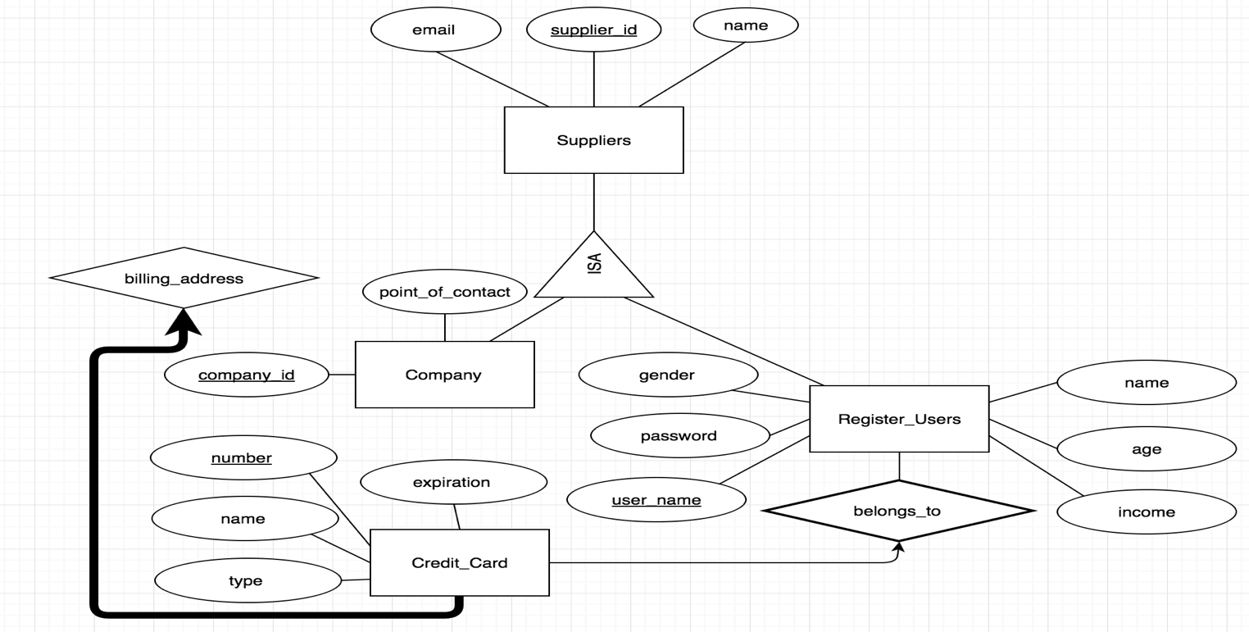

**Figure 4: Registered_Users, Suppliers, Company, Credit_Card ER Diagram**

Similar to the **Company** table, the **Register_Users** table has a foreign key that links to a unique *supplier_id*. The *supplier_id* cannot be null, that way every **Register_Users** has a corresponding **Supplier** entity. Like the **Company** table, the **Register_Users** field will be deleted if the **Supplier** field is deleted. Unlike the **Company** table, the **Register_Users** use their own *username* attribute as the primary key. Since every *username* must be unique and is the main way other users will identify one another, we thought *username* would suite as a better primary key.

The **Credit_Card** is a separate entity. This allows each **Register_User** to have multiple credit cards and multiple billing addresses. It records the *username*, credit card *number*, and *billing_address_id* of each member. It also uses these two foreign keys as the table’s primary key.

* 1. **Rating**

Rating is an important measure for a seller’s reputation. A user might want to know what rating a seller might have. Many websites now have rating system for sellers. For example, sellers on eBay can earn stars based on the number of ratings they get [4]. The rating system on this website can be modeled by a **Rating** entity, which has a relationship with a single **Register_User**, who create the rating, and a single **Supplier**, who the register user rates. The application quality entity **Rating** is created with primary key *rating_id*, a scale based non-key attribute *value*, and a textual non-key attribute *explanation*.



**Figure 5: Rating ER Diagram**

The *value* is a scale attribute that can be selected from 1 star to 5 stars. The *explanation* is a textual attribute that allows a user to explain why one gives such scaled-rating or any additional comments. A seller will also have an average rating showing on his/her profile. The average rating calculates the mean of each rating value then rounds to the nearest star scale.

For the table for **Rating**, there is a partial key *rating_id*, in addition to the *explanation* and *value* attributes. There is also a foreign key pointing to the *username* of the reviewer and the *supplier_id* of the company or user being reviewed. These two foreign keys help combine **Rating** with the **by** and **has** relationships. Also, in the ER diagram, **Rating** is a weak entity to **Supplier**. So if the **Supplier** deletes their account, then all the ratings for them will also be deleted. This is done with the ON DELETE CASCADE line where the *supplier_id* is declared a foreign key. **Rating** is given a primary key which combines the *supplier_id* with the partial key *rating_id*.

We also have a review for items called Item_Review. It takes the and *item_id* instead of *supplier_id*.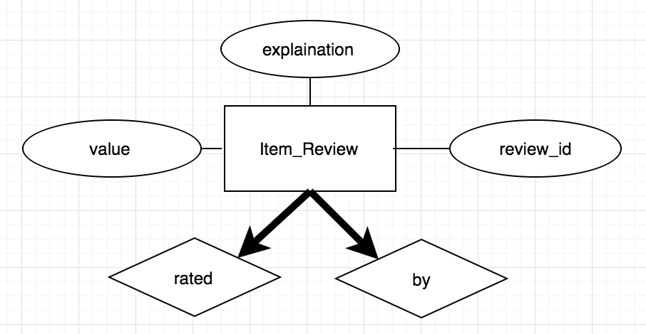

**Figure 6: Items_Review ER Diagram**

* 1. **Browsing**

Users are able to browse the items by traversing the category tree (Appendix C). When a user chooses a category, the user will want to know all of the categories that are directly linked to that current category. The tree traversal algorithm to be implemented will follow a derivative of the breadth-first search algorithm. At each point, they are given a summary of all the items that appear in that category. For example, if the user is in the “Women’s” category, the provided categories are “Boots”, “Flats”, “Pump”, “Sandals”, “Sneakers”, and “Wedges”. However, in traditional breadth-first search algorithms, the other nodes in the same level as the previously mentioned categories, will be shown. So our form of the algorithm will limit the traversing within the current node and its children.

Another important browsing feature is to allow the user the ability to traverse both ways through the tree, including moving downwards and upwards through the tree. The user will be able to return to the parent node of their current category. In addition, there will be a home button to traverse the user back to the root node.

In the browser bar, user can access their account information. This includes their profile, feedback, and settings. Profile contains their personal information, items they are selling, current bids, and history. Feedback has ratings and reviews. Settings include login information, credit card information, and shipping/billing address.

There will be a homepage which consists of the current deals and other features usually found in homepages. This homepage is not located anywhere in the classification tree, yet contains various items from different categories.

During our research of other shoe/clothing sites, we were attracted to a certain type of user interface that made browsing very easy and fast. Particularity, Macy’s online store featured a row of tabs near the top of the page. These tabs were the major categories of clothing, “Men”, “Women”, etc. When the user selects one of the tabs, a drop down menu appears, listing all of the categories within that major category. Furthermore, under those categories were subcategories that were indented to easily show its lower levelness. We found this interface in other sources as well and we find this way of browsing to be the most user-friendly because it gives the user a broad overview of the classification tree. TechFam will follow this structure of browsing.

* 1. Searching

On shopping websites, like Amazon, a user might want to search for a series of specific items. This can be modeled by two kinds querying, “User search Items”, and “User choose Categories then search Items”, as shown in Figure 5.

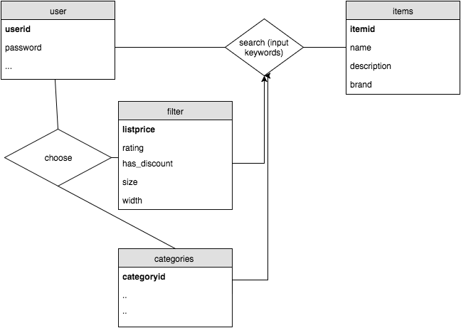

**Figure 7: Searching Process Diagram**

If a user chooses to input keywords, the database will look for items that contains these keywords. A user can also choose certain categories or other filters first then input keywords to narrow down the results. Attributes in Sales_Item like *name, description, brand,* etc. shall be searchable.

* 1. **Sale**

Items on sale will be the ones not auctioned off. We will create an option for buying the item now. When the user enters a specific item description, that item information will be pulled from our database. The user interface will display all the items matching that description. The user will be allowed to add items to the cart, use their credit card information and check out. After the transaction has completed the item count will decrement. The transaction information will remain in the system for six months and will be stored using the ER diagram in Figure 6.

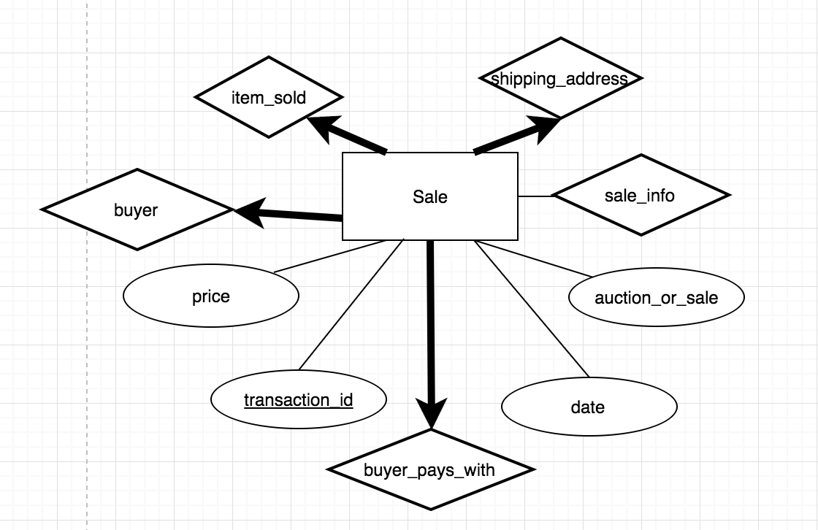

**Figure 8: Sale ER Diagram**

We created a table call Sale, where we had *tansaction_id* as the primary key. The table checks if it is an auction or a regular sale, using a Boolean. The foreign key that was referenced from Sales_Itemwas item_id, where it was linked on the ER diagram by relationship *item_sold*. It also includes *credit_card_number* which is referenced from the Credit_Card entity*.* This credit card information belongs to the user that bought the item.

* 1. Bidding

Unlike many shoe websites, our database will have the option of auctioning items. A user can access these items by searching through the pull-down menu and clicking on an item through the categories included, as well as entering a specific item name through the search bar. The database will retrieve information and after clicking the auctioned items option the user will be able to view the item. The user has the option to sort items based on price from highest to lowest or vice versa.

*Bidding Rules:*

•    Users must remember each bid is a contract.

•    Each item will have a specific time stamp listed under description.

•    Bids can only be canceled 24 hours prior to time stamp deadline.

•    Bids will be in 2 dollar increments.

*Selling an item:*

•    Under options, select selling button and Users can only sell one item at a time.

•    Select the item for sale and give a brief description.

•    List the timestamp value for the starting and ending.

•    Select the reserve price for the item.

•    Review everything and select the confirm button.

•    You will be notified when the auction has ended and who had the winning bid.

We will feature manual bidding and automatic bidding. First let’s talk about the manual way, where the user enters a bid value that is at least $2 more than the current highest bid. The user will be notified when someone overtakes them as the lead bidder. On the other hand, we have automatic bidding, where the user will be prompted to enter the maximum value they are willing to pay for the item being auctioned off. The system will bid $2 more than the current highest bid until your bid reaches the maximum value you are willing to play or the auction ends. The user with the highest bid wins, and pays the amount they bid. For both bidding options at the end of the auction, the user with the winning bid will be notified, that he or she has won. The system will charge the user’s credit card with winning bid amount and after receiving the payment, the seller will be required to ship the item. The transaction will stay in the system for 6 months. The user can view their current bids under the account options.

The **Auction** will have a *time_stamp_start* for the start of the auction and a *time_stamp_end* for the end of the auction. The auction will record all the bids that users place and these will have a relationship **(item_auctioned)** to the sale items.

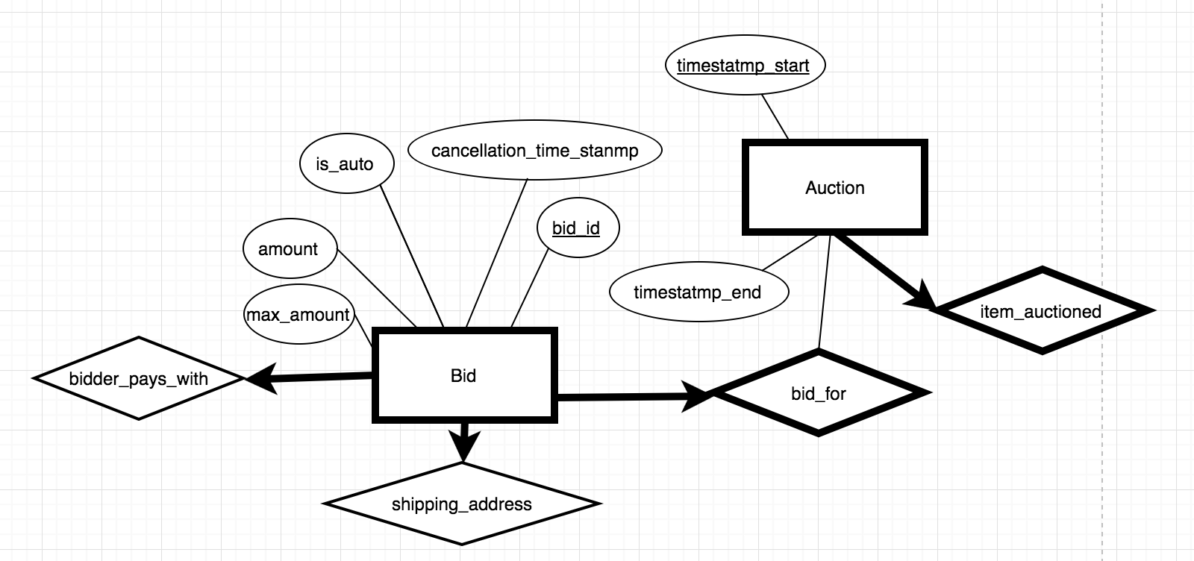

**Figure 9: Auction and Bid ER Diagram**

The table on the left was created for Auctions taking place, where it included timestamps for start and end. We referenced the *item_id* from the Sales_Items entity through the relationship of *item_auctioned*. Our partial key is *timestamp_start,* which is sourced from *item_id.* This could only be done using on delete cascade. *timestamp_end* refers to the time when the auction ends. Timestamps are recorded as integers based on the Unix machine time. This method is simpler than using traditional timestamps and yields the same performance.

For the Bid entity, we created a table called Bid, where we had *bid_id* as the primary key, *amount* as a decimal because it can not exceed more than 7-digit value max. *cancellation_timestamp* holds the time when the auction is over. u*sername* lets us know who is the bidder. *is_auto* is a Boolean value that determines if automatic bidding feature is turned on. *max_amount* determines the highest bid before automatic bidding ceases. Our foreign key was *item_id* and *auction_timestamp_start,* which are referenced through Auction. Again we had to use an on delete cascade if the they are removed.

* 1. Order and Sale Reports

With everything set up, it is important to consider how our system keeps track of all the orders that go through the system. We want to be able to generate a weekly report for each category that we are selling. This will not only inform us on how we are doing in terms of revenue but also help us monitor consumer behavior. By recording and analyzing reports of user activity, companies can improve their sites functionality.[9] Having this functionality in our application and design, we believe our marketing team will be able to take a full advantage of this report function and produce the most effective marketing strategy that will help to maximize company’s profit.

Moving into the implementation of our report, each report will carry a specific report id that is relevant to the seller account detail and the time period for which the report is on. Our goal is to make our report as informative and dynamic as possible. We want to create an interface that allows our users to easily assess their data with a few clicks of a button.

Our design will include a bunch of useful keywords that relate to type of data that will be displayed such as total revenue, total cost, number of purchases, etc. In the backend of this functionality, we will use these keywords and put together a query that will access our database and pull up the request data and present them in a neat view.

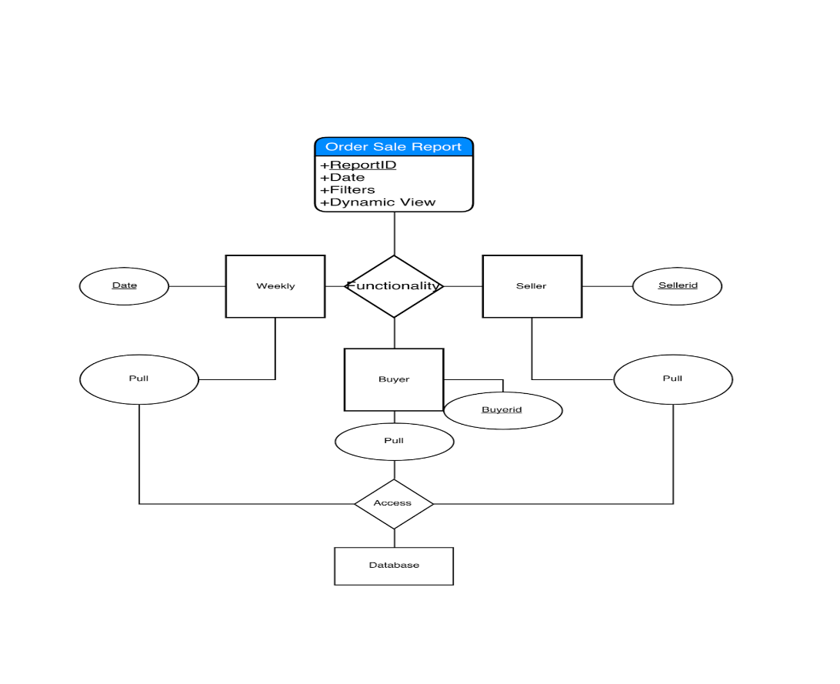

**Figure 10: Order Sale Report Process Diagram**

* 1. Delivery

The other important thing that we are focusing on is our delivery system. We understand that it is our duty to fulfill our customers’ orders with the best service possible. This is why we are taking extra steps to secure every single transaction amongst our users.

With our delivery system, we will generate a unique id (*shipping_id*) for every delivery that is only available for the buyer, seller, and our engineers. Nevertheless, this id will only be created after a confirmation of payment has been posted. This means there will be lower chance of error for shipping confirmation. Why compete in the shipping market when companies like UPS, FedEx, and DHL have proven themselves to be among the best in the industry. While companies like UPS help to provide their customers with useful developer API, we aim to utilize their API to create the best interface for our users without traversing to another website. [10] We want to provide the tracking number for the shipment to allow users to see the status of their shipment from our website. We hope that our efforts in providing a friendly user interface will keep our customers satisfied with our products and services.

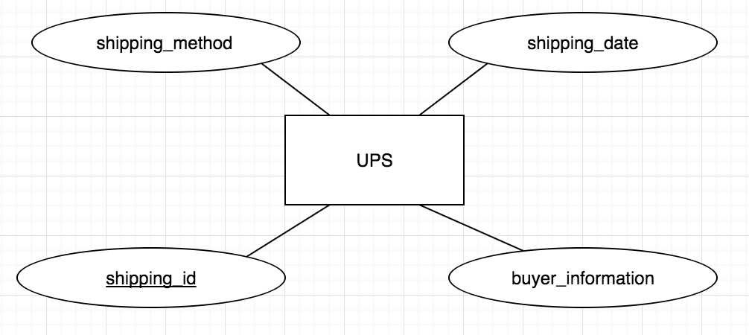

**Figure 11: UPS ER Diagram**

For the entity in the ER diagram of UPS, created a table called UPS, created tuples of its attributes. Used *shipping_id* as the primary key. We have an attribute that stores the method of shipping (*shipping_method*). Another attribute is used to record the date of shipping (*shipping_date*). For the foreign key, we used *transaction_id* because once a sale has been made *sale_info* relationship is accessed, where it gives the transaction id to the UPS service. *address_id* keeps track on where the package is being shipped to.

* 1. **Custom Shoes**

Unlike most sites, our team decided to create a custom shoe feature. We researched Nike’s custom shoe system for guidance. [6] First, the user will click on the custom shoe feature in the browser bar. Then, they can pick between a men’s, women’s, boys’, or girls’ shoe. After that, they can pick a particular category of shoe, such as athletic, casual, etc. and then pick a subcategory, such as running shoe or cleat. From there, the user has several features they can choose from a multiple choice list. These features include the size of the shoe, the width of the shoe, the side, back, and front image, tong style, the shoe sole style, and the coloring of the shoe.

The way the custom shoe information is stored is in the **Custom_Shoe** entity. This entity is a sub-entity of the sales items but it contains additional information for the customization process such as a side, back, and front image labels. In our database, we will store every possible combination of custom shoes in the **Custom_Shoe** entity. Then, during the creation process, as the user selects new attributes, different images will be displayed on screen, based on the default and user selections.



**Figure 12: Custom_Shoe ER Diagram**

We created a table based on the entity Custom_Shoe, each custom shoe you design will allow you to view the front, side, and back image. It will allow you to customize the tong, sole, shoe and color style, as shown in the ER diagram. Again the primary key is *item_id* because selecting a specific item allows you to customize it, where on delete cascade is used. The foreign keys include the relationships of *side­­_img_id, front_img_id,* and *back_img_id*, which reference the Image entity. We also have a foreign key of *item_id* which references Footwear.

* 1. Customer Service

We are providing users a way to contact us. This bonus feature allows us to connect us with the users. Users can email or call us. We also provide a FAQ page that helps users navigate better. This page also helps users get answers to common questions. Customer service options will be located at the bottom of every page. This feature also helps us get feedback about our services, which provides a scope for improvement.



**Figure 13: Customer_Service ER Diagram**

We created the table Customer_Service as an extra feature. The primary key for it is *customer_service_id.* We created a tuple of *faqs* for customers to access frequent questions, we also included an *email*, and a *phone_number*. The foreign key for it is *phone_number*, where it is referenced from the entity Phone.

1. **MASTER ER DIAGRAM**



1. **TECHNOLOGY SURVEY**
   1. **MySQL**

We selected MySQL as our database because it is a relational database, meaning that it is suited for storage and retrieval. The relational part of the database allows for an easier and wider range of access to data that will allow us to manipulate the data in our system to its full potential.

MySQL is easier for us to use, given our limited experiences in database language. Moreover, MySQL is also an open source software that is owned by Oracle, which means that our group will not have to spend any money to use it. Needless to say, MySQL is also very popular amongst programmers. There is a great online community that we can fall back on when we are in trouble.

We did take several limitations of MySQL into account including poor performance scaling, limited functionality, and lesser overall quality compared to other database languages.[11] We decided that poor performance scaling would not be a big issue due to the fact that we are not operating with a ton of data. Next, we are also not anticipating a great number of functionality to implement inside our database, as we will have backend codes that will do the job. Our intended use of the database should be straightforward – push and pull requests. Lastly, quality and stability is not something we are currently targeting for in our prototype phase. Our goal to set up the environment first and make everything work before we optimize to our environment.

|  |  |
| --- | --- |
| Pro | Cons |
| Easy to use | Poor performance scaling |
| Open source | Limited functionality |
| Great online community | Inferior quality to top-tier databases |
| Suitable performance | Stability issues |

**Figure 14: Pros and Cons of MySQL**

* 1. **Frontend**

Since our team has the most experiences in JavaScript, we decided to design our front end in JavaScript, HTML 5, and CSS. We chose JavaScript because it remains one of today’s most used languages in websites. It is easier to code than server-side languages, and it offers a great range of variety when it comes to dynamic views and displays for our users. Moreover, JavaScript is entirely a client side programming, meaning the computation is done on our users’ computer rather than having data sent back to the server and back out to the user. We rely on this mechanism to make it easier for our servers, so we can reach up to more users.

HTML 5 and CSS will be used to make our website more visibly attractive to our users. We hope that our front-end code will be able to take a full advantage of our design to create the best user experiences possible. Nevertheless, these two languages are easy to learn and implement since they are ubiquitous in today’s websites.



**Figure 15: Frontend Programming Languages**

* 1. **Backend**

We want to link our frontend code to our database through a backend written in Java. Mainly because Java is still one of the most popular languages in the industry and many of us have experience with it. Java offers a wide range of functionality and online communities to help us achieve what we want.

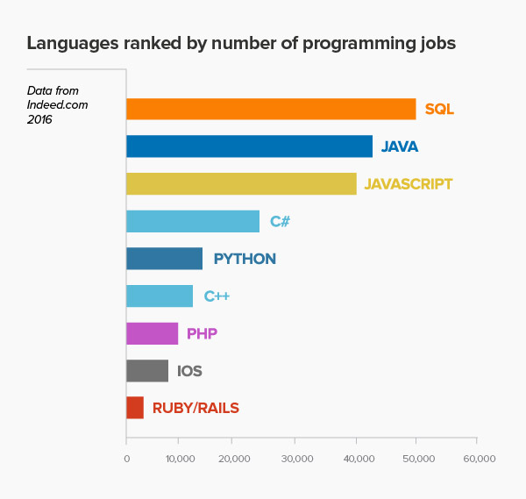

Figure 16: Most Used Programming Languages

* 1. **Other Technologies**

**Draw.io –** We used Draw.io to do most of our Entity-Relationship diagrams. It is an easy to use online program that allows us to organize our diagrams neatly.

**Asana –** We use Asana to plan most of our daily activities and group goals. It offers a clear view of what our goals are and how to get there, if we put in the work to create it.

**GitHub –** GitHub is where our repository is located. We have access to our peers’ work and to the progression of our big project. Moreover, it is very convenient for each of us to edit and make commentary about others work.

**GroupMe –** We use GroupMe to communicate with one another.

1. **CATEGORY TREE** **AND NORMALIZATION**



Figure 17: Classification Diagram

**SCHEMAS IN THIRD NORMAL FORM**

address

|  |  |  |  |  |  |  |
| --- | --- | --- | --- | --- | --- | --- |
| address_id:  integer | app_num:  string | street_address:  string | city:  string | state:  string | zip:  integ­er | supplier_id:  integer |

auction­

|  |  |  |
| --- | --- | --- |
| timestamp_start:  timestamp | timestamp_end:  timestamp | item_id:  integer |

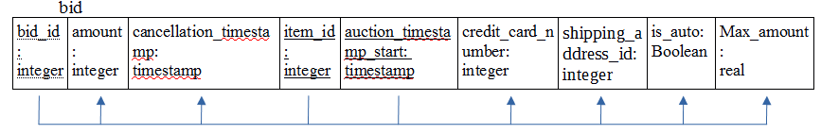

category

|  |  |  |  |
| --- | --- | --- | --- |
| category_id:  integer | description:  string | category_name:  string | parent_id:  integer |

company

|  |  |
| --- | --- |
| point_of_contact:  string | supplier_id:  integer |

contact_by

|  |  |
| --- | --- |
| phone_number:  integer | supplier_id:  integer |

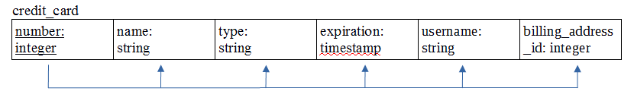

custom_shoe

|  |  |  |  |  |  |  |  |
| --- | --- | --- | --- | --- | --- | --- | --- |
| tong_style:  string | sole_style:  string | shoe_style:  string | color:  string | side_img_id:  integer | front_img_id:  integer | back_img_id:  integer | item_id:  integer |

customer_service

|  |  |  |  |
| --- | --- | --- | --- |
| customer_service_id:  integer | email:  string | faqs:  string | phone_number:  integer |

footwear

|  |  |
| --- | --- |
| size: string | item_id: integer |

has_visual

|  |  |  |
| --- | --- | --- |
| item_id: integer | img_id: integer | color: string |

image

|  |  |
| --- | --- |
| img_id: integer | image: blob |

pays_with

|  |  |  |
| --- | --- | --- |
| username: string | number: integer | address_id: integer |

phone

|  |
| --- |
| phone_number: integer |

rating

|  |  |  |  |  |
| --- | --- | --- | --- | --- |
| rating_id:  integer | explanation:  string | value:  real | username:  string | supplier_id:  integer |

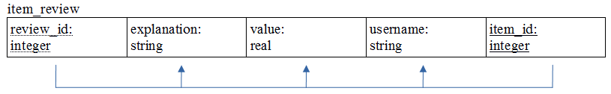

register_user

|  |  |  |  |  |  |  |
| --- | --- | --- | --- | --- | --- | --- |
| username:  string | password:  string | age: integer | gender:  string | income:  real | name: string | supplier_id:  integer |

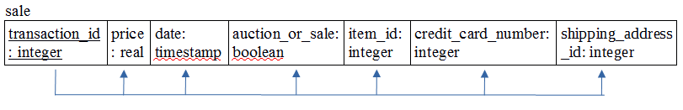

sales_item

|  |  |  |  |  |  |  |  |  |  |  |
| --- | --- | --- | --- | --- | --- | --- | --- | --- | --- | --- |
| item_id:  integer | count:  integer | brand:  string | list_price:  real | state:  string | description:  string | name:  string | reserved_price:  real | category_id:  integer | supplier_id:  integer | address_id:  integer |

supplier

|  |  |  |
| --- | --- | --- |
| supplier_id: integer | email: string | name: string |

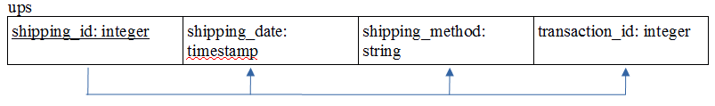

1. **SQL STATEMENTS** 
   1. **Sales Item**



**Figure 18: SQL Table for Sales_Item**



**Figure 19: SQL Table for Footwear**



**Figure 20: SQL Table for Address**



**Figure 21: SQL Table for has_visual**



**Figure 22: SQL Table for Image**

* 1. **Categories**



**Figure 23: SQL Table for Category**

* 1. **Suppliers**



**Figure 24: SQL Table for Supplier**



**Figure 25: SQL Table for Phone**



**Figure 26: SQL Table for contact_by**

* 1. **Company**



**Figure 27: SQL Table for Company**

* 1. **Registered Users**



**Figure 28: SQL Table for Register_Users**



**Figure 29: SQL Table for Credit_Card**

* 1. **Ratings**



**Figure 30: SQL Table for Ratings**



**Figure 31: SQL Table for Item Review**

* 1. **Sale**



**Figure 32: SQL Table for Sale**

* 1. **Bidding**



**Figure 33: SQL Table for Auction**



**Figure 34: SQL Table for Bid**

* 1. **Delivery**



**Figure 35: SQL Table for UPS**

* 1. **Custom Shoes**



**Figure 36: SQL Table for Custom_Shoe**

* 1. **Customer Service**



**Figure 37: SQL Table for Customer_Service**

1. **CONCLUSION**

There were many options to choose from when selecting a database. After our first meeting we gathered ideas from everyone and ended with a shoe retailers’ database. The shoe industry is enormous and there were many features that we wanted to talk about besides the given ones. Everyone did their research on ideas and how we would incorporate the given features. The bonus features we selected were custom shoes and customer service. We assigned each person separate features, where each would do research on their specific topic and write a rough draft for analysis, we discussed how each person should implement certain ideas pertaining to their feature.

Next, we broke up into 2 teams, we had 3 on editing, while the rest on presentation. The biggest challenge we faced was making sure the information lined up perfectly between each topic because some features are closely connected to each other. Our main goal was making sure we developed a database that was user-friendly, yet offered complex features. Overall, phase one was a success where we implemented the design specifications according to the criteria.

As we move forward with our design we will implement a website that represents our database in a consumer friendly manner. Our website will allow the user to quickly locate desired items and purchase safely within our database on a protected web server. To do this we will apply browsing and searching techniques using the Breadth-First Search algorithm. Another addition will be Order and Sales Report, where we will store the transaction information in our database for business purposes. Most importantly, the database will be ready for real-world use.

1. **FINAL SYSTEM FRAMEWORK**

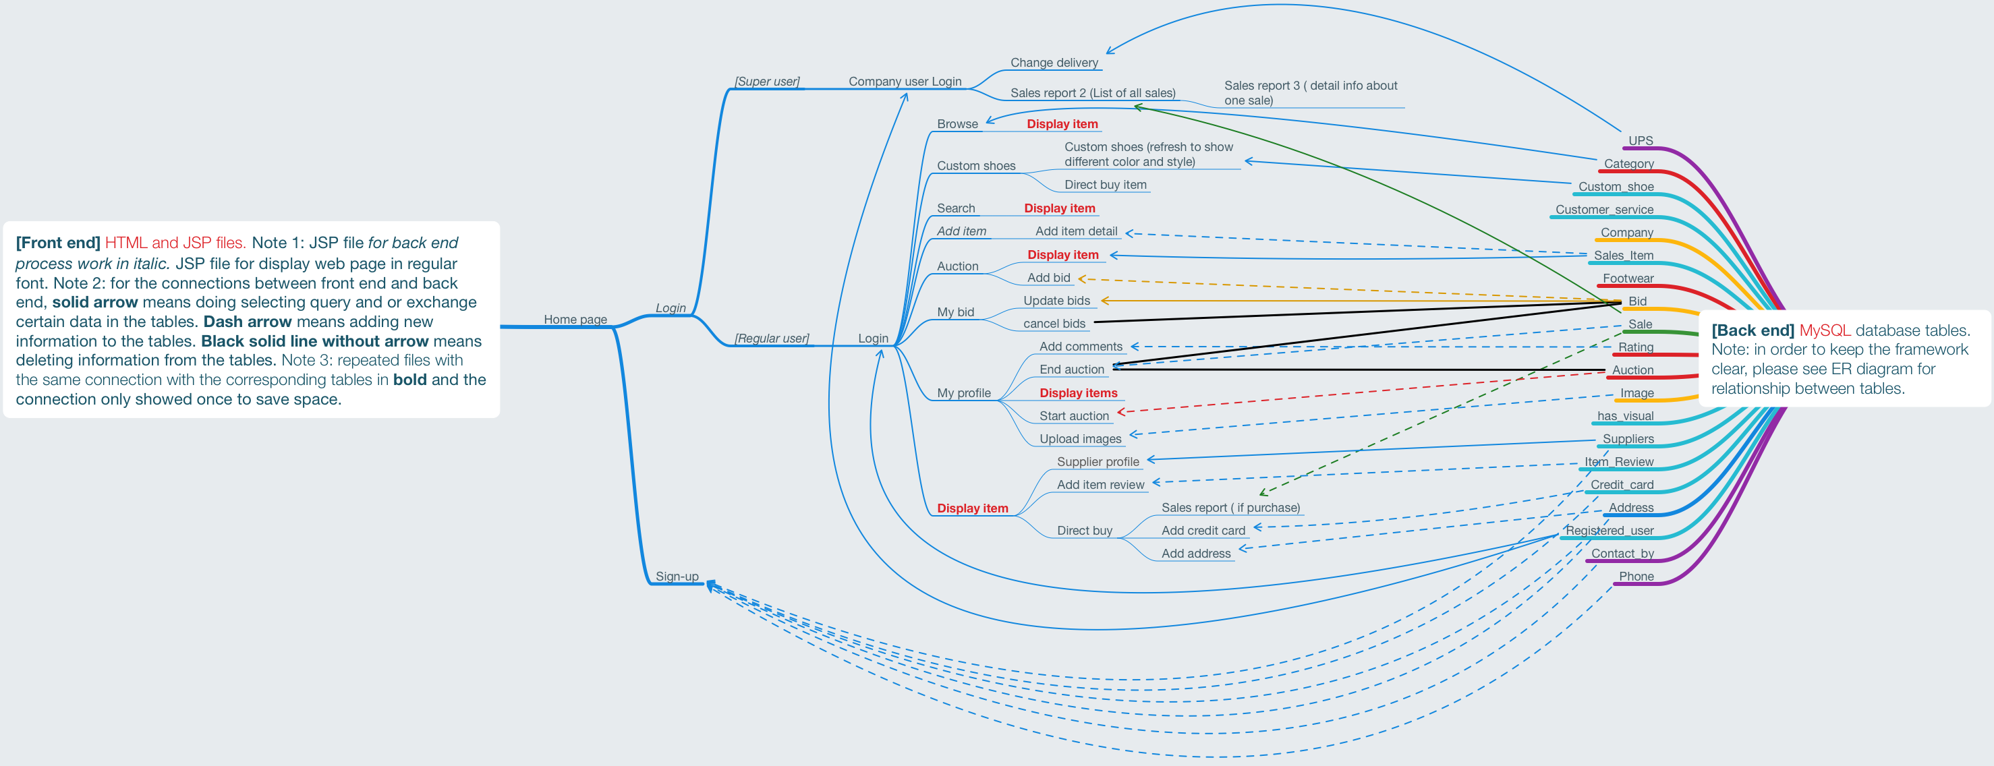

**Figure 38: Framework**

The framework above shows main relationship between the frontend webpages and backend database. Besides the notes showed in the graph, a few essential explanations are as follows:

1. Login is divided into super users and regular users’ login, where super users can change delivery and view sales reports. Regular users are the customers. After login, they can browse through different categories, add items, place bids for auctions and directly buy items, etc.
2. For auction, users can find a list of items under Auction page. Once they bid on one item, they can trace their bid in My bid. In My bid page, users can either update their bid value or delete existing bid.
3. Under My profile, users can start an auction, and they can choose to end an auction as well. End auction will also delete all the bids tied to the auction item and the auction will be deleted from Auction page. This transaction will be added to Sale table. Thus End Auction has two black solid lines and one dash line as its connection.
4. **REFLECTION**

Looking back, we set really high expectations for ourselves and wanted to create a shoe enterprise that reflected big corporations like Macys and eBay. Our main goal was to bring the features offered by them as well as our own, but at the same time creating a consumer-friendly environment. Our main features included: Sales Items, Categories, Suppliers, Company, Registered Users, Rating, Browsing, Searching, Sale, Bidding, Sales Reports, Delivery, Custom Shoes, and Customer Service. We ended up achieving all of them except Customer Service and had an issue with Register Users. We didn’t implement Customer Service, the main reason was due to the lack of time and conflicts with other features. Another feature that we implemented was Registered Users, but during the presentation it failed, possible reasons for the bug due to duplication of data or the email confirmation was not sent properly. A sub-feature that we added was rating items, initially, we set out to just rate users, but ended up being a nice feature. Another feature that we didn’t have in mind when we were setting goals was images. It ended up being a really nice feature for all the items, especially custom shoes. For the most, we were successful in hitting the goals we set, but some fell out due to the reasons listed above. Even though we hit a majority of the goals, all we can say is setting goals is easy, but achieving them not so much.

1. **APPENDIX A – GITHUB GRAPHS**



1. **APPENDIX B – ASANA SUMMARY**



1. **APPENDIX F – DATABASE STORAGE**

After completing our ER and schema designs for the important information we needed to store, we created our database and began filling it with sample data. Our goal was to fill out enough information to make the site feel like it was already up and running with real users. Below lists all the data stored in each table of our database, in alphabetical order. Note that some fields will be missing, due to difficulty of fitting all of the information on the page.

**Table 1: Address Table**

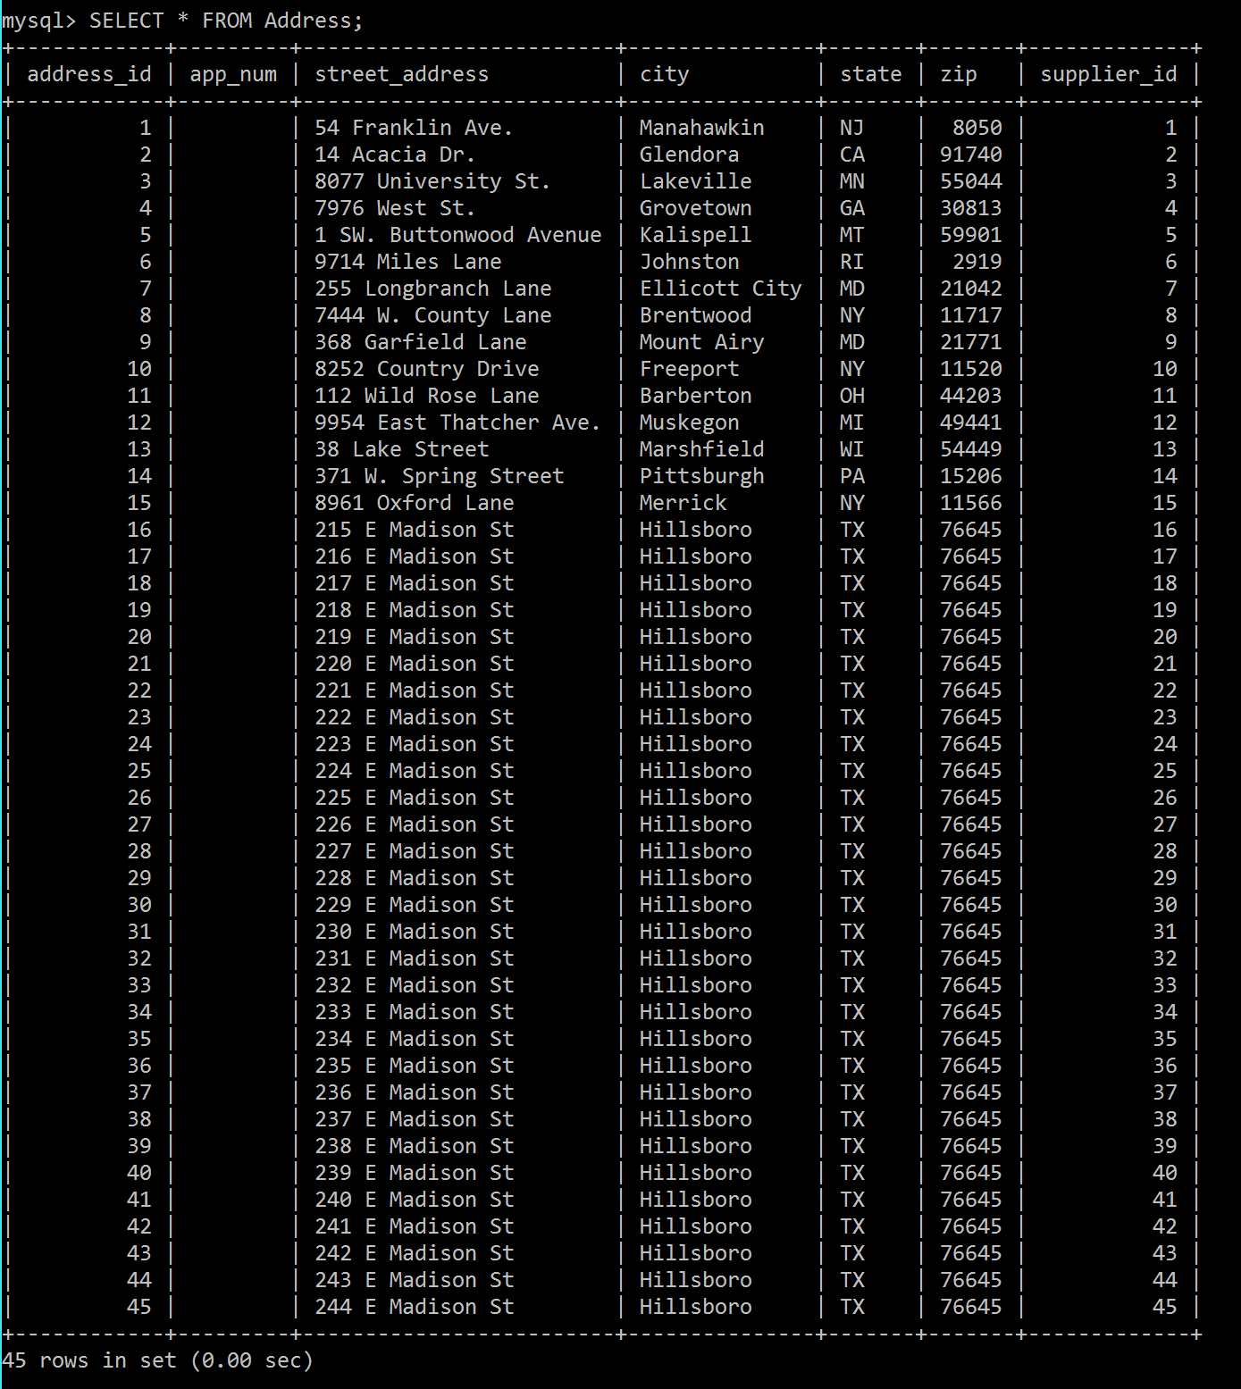

**Table 2: Auction Table**

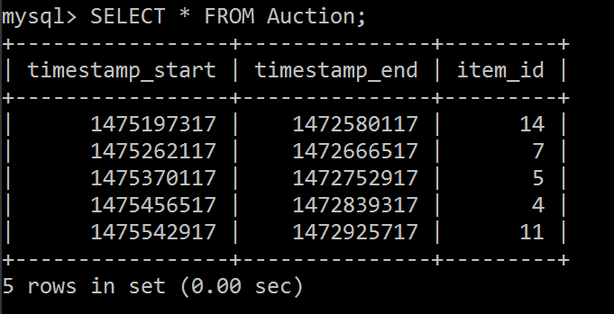

**Table 3: Bid Table**

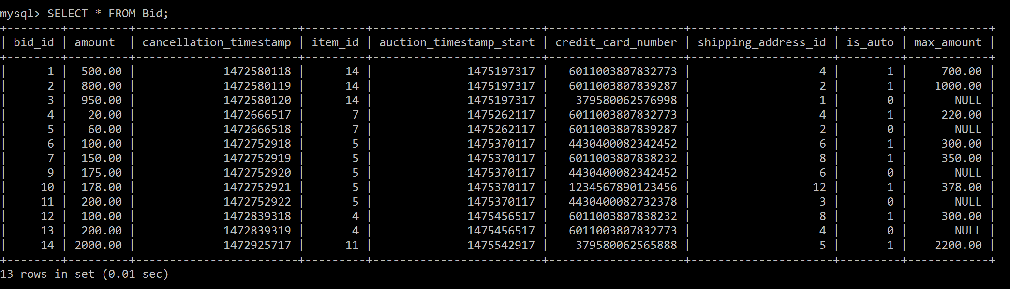

**Table 4: Category Table**

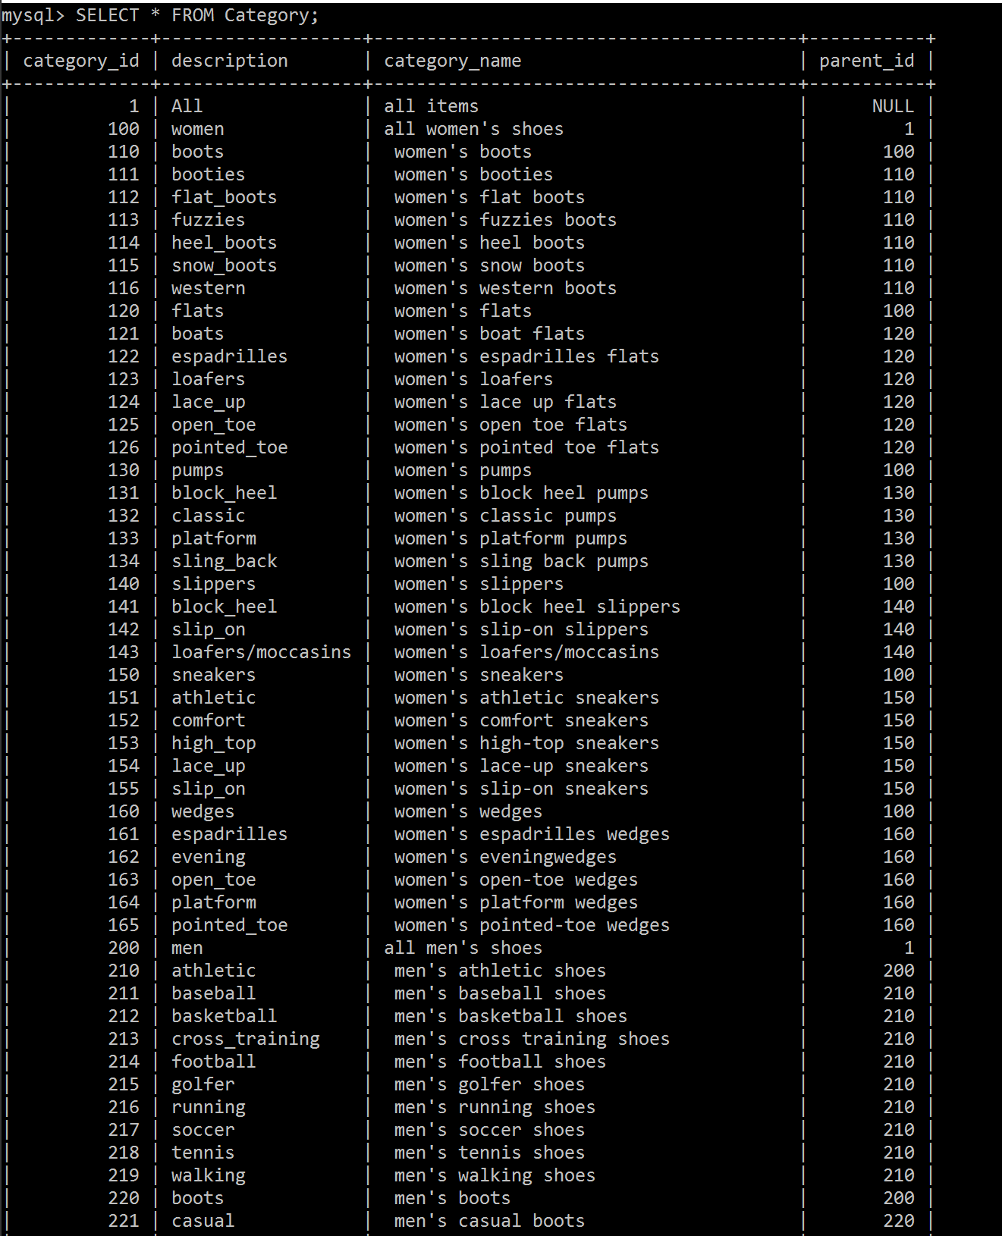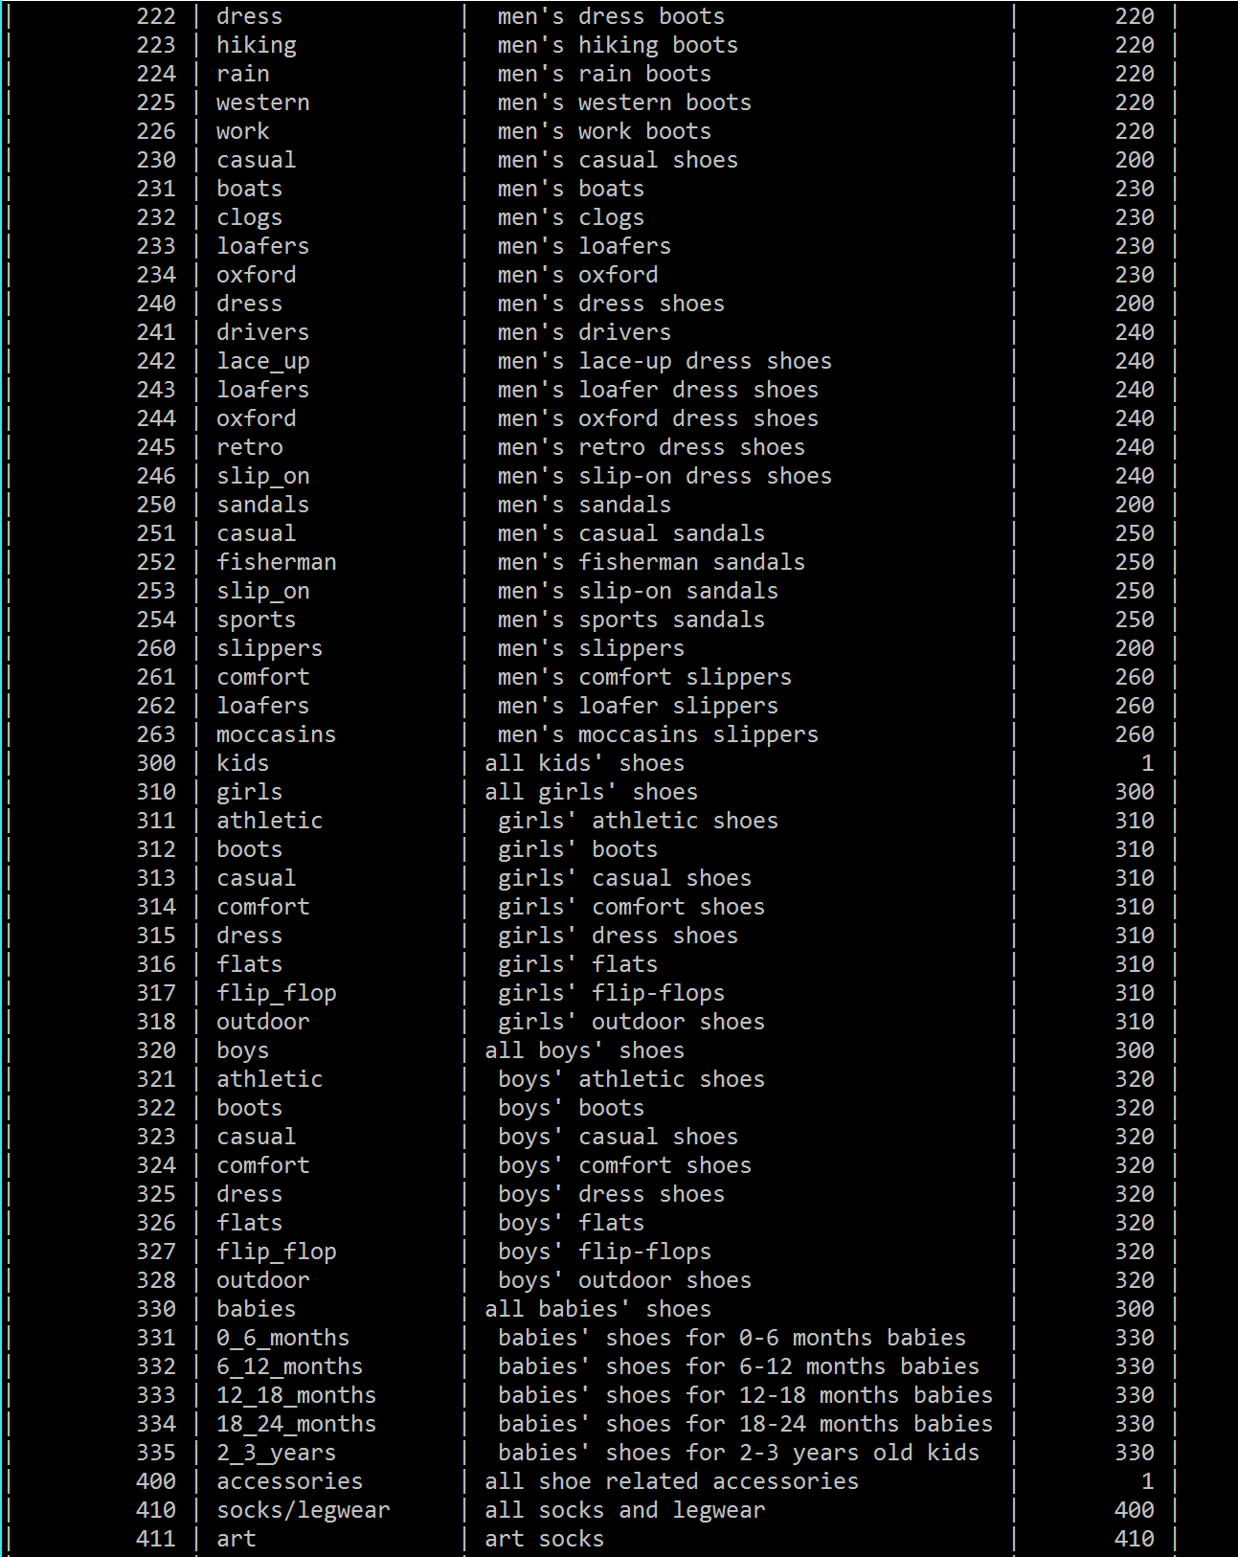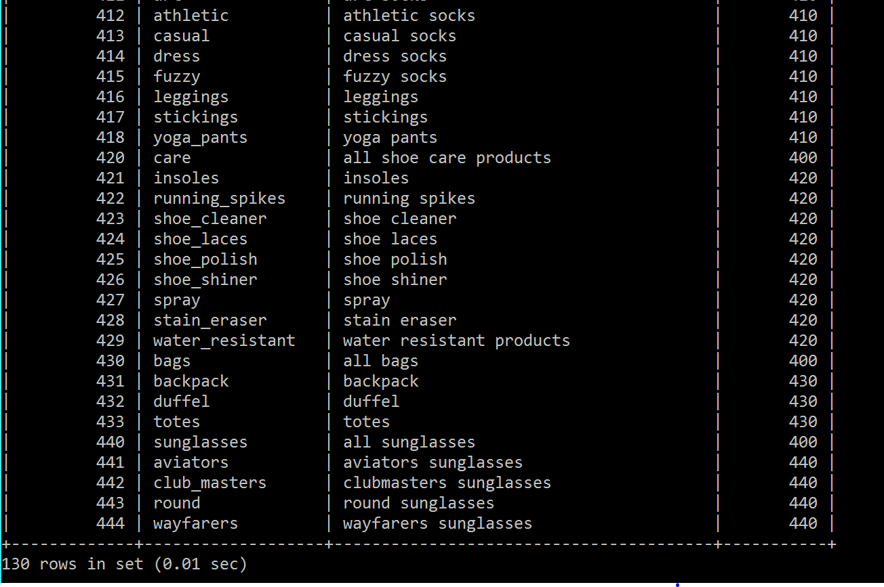

**Table 5: Company_Data Table**

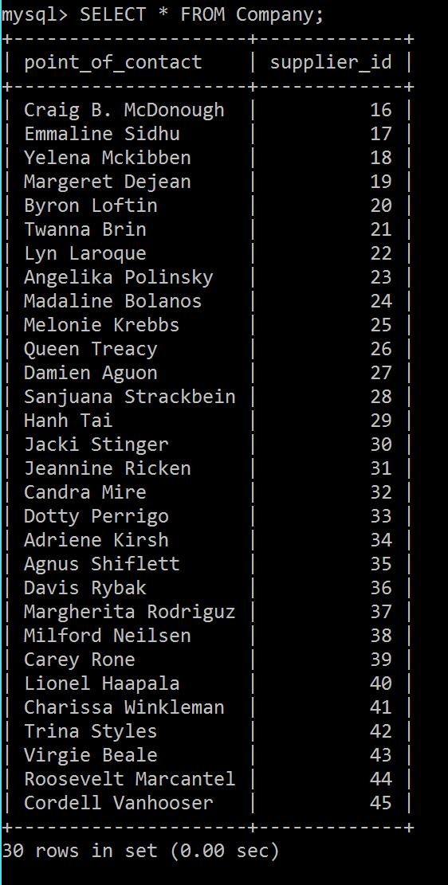

**Table 6: Contact_By Table**

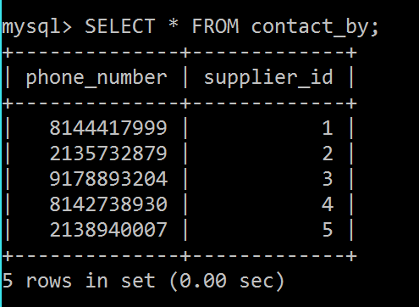

**Table 7: Credit_Card Table**

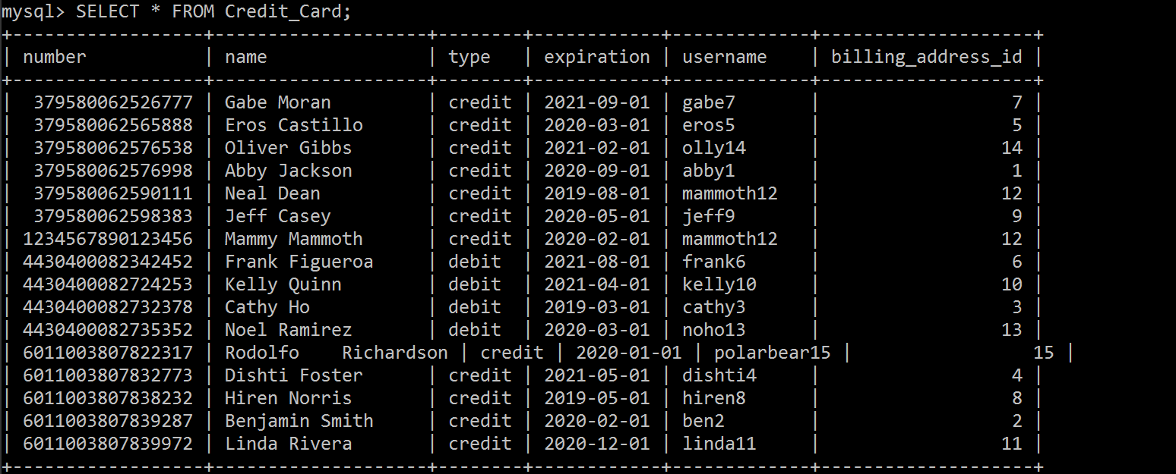

**Table 8: Custom_Shoe Table**

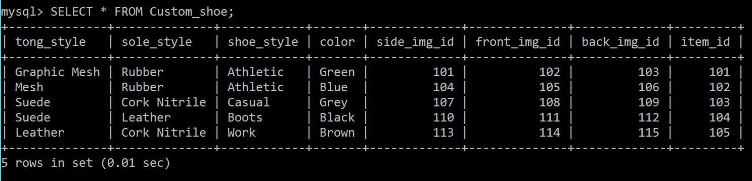

**Table 9: Customer_Service Table**

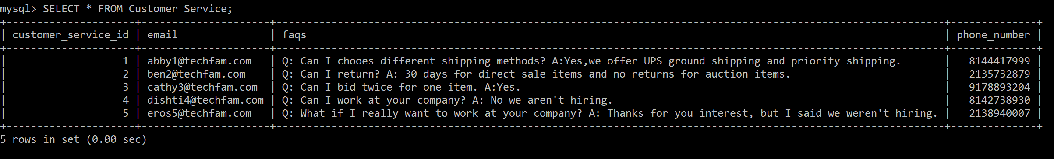

**Table 10: Footwear Table**

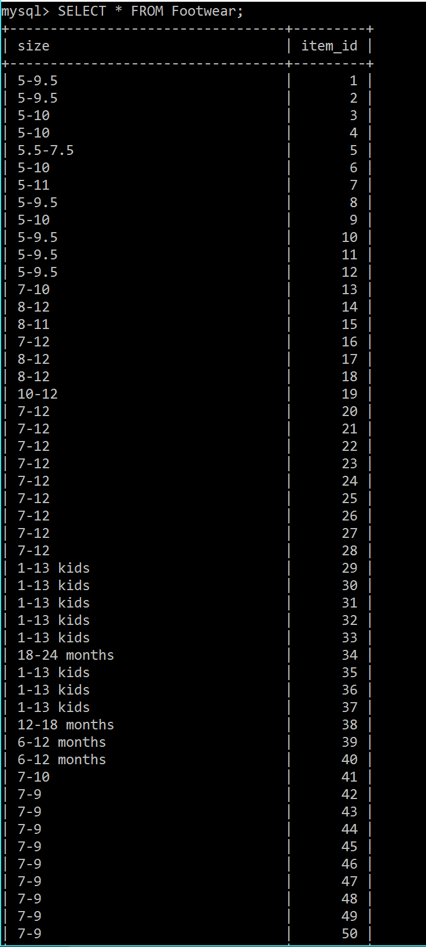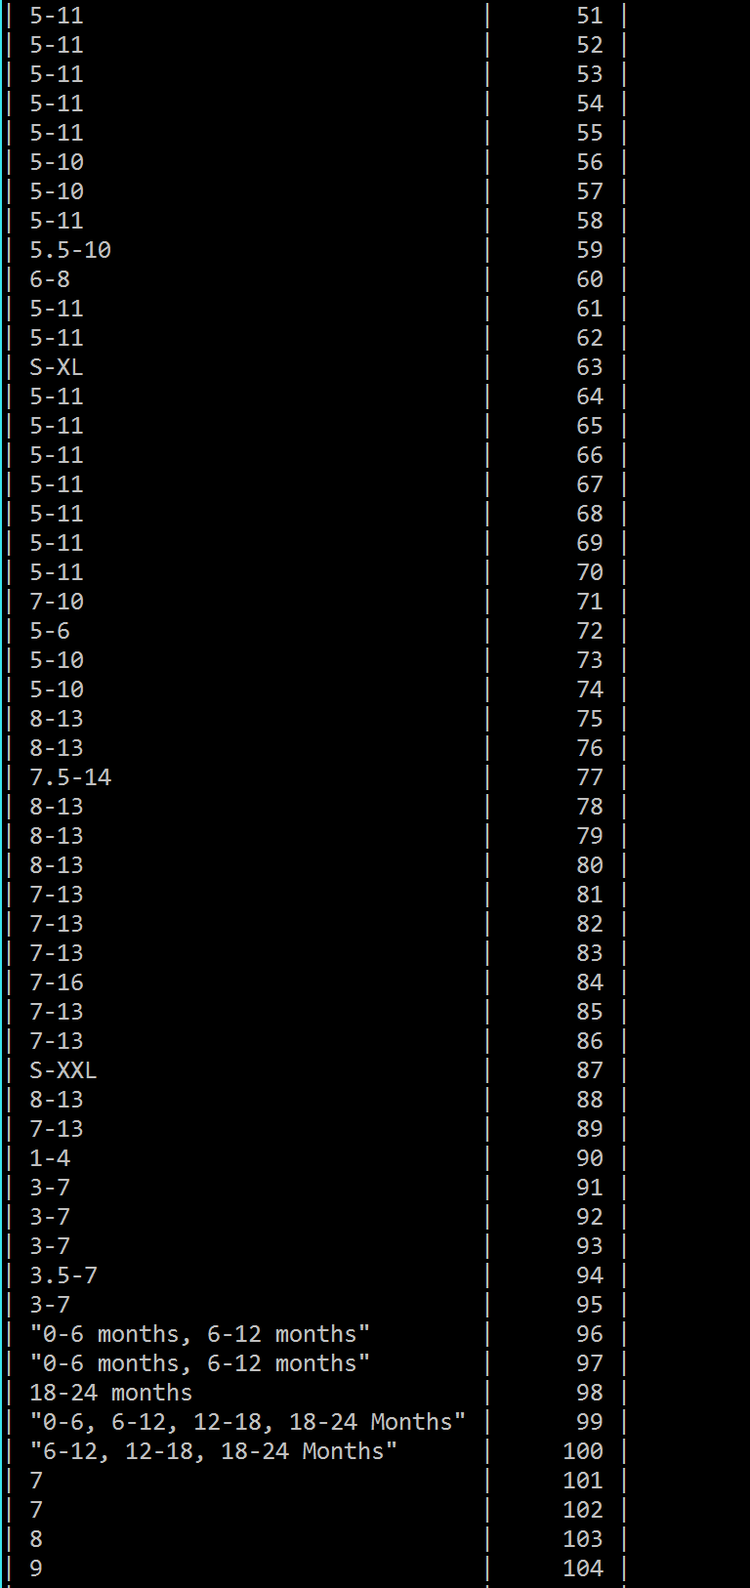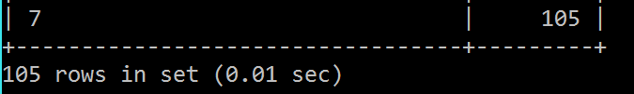

**Table 11: Has_Visual Table**

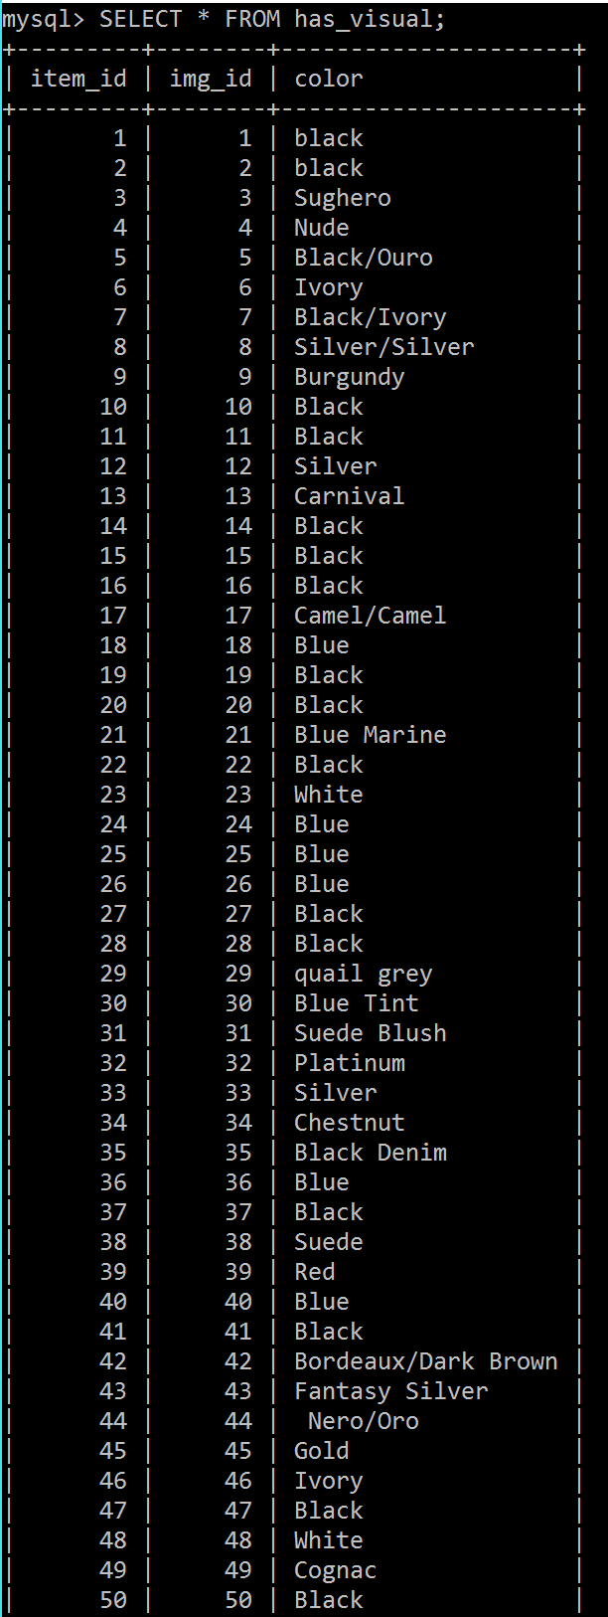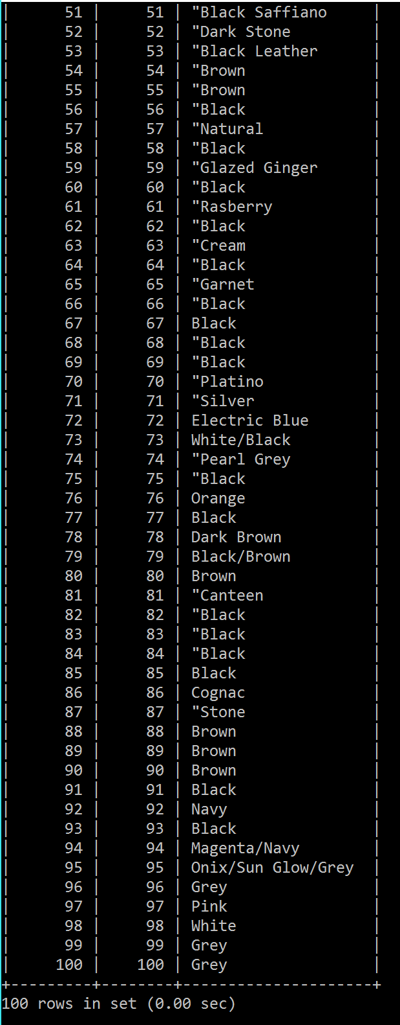

**Table 12: Image Table**

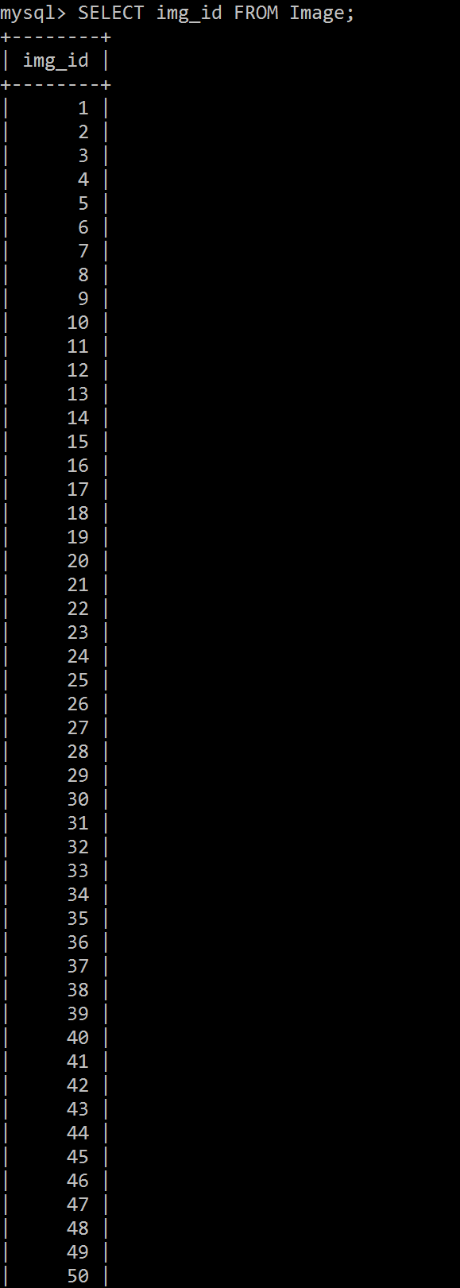

**Note that this table also has a column of images, but this could not be printed out due to the size of the data. Also note that the real table goes all the way up to Image_ID 115.**

**Table 13: Phone Table**

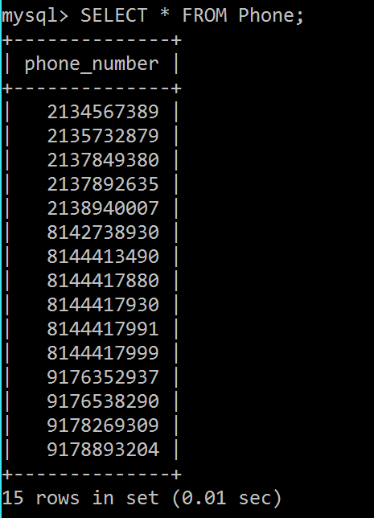

**Table 14: Rating Table**

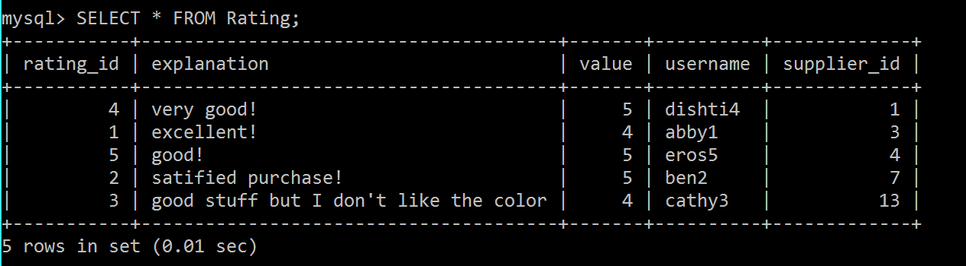

**Table 15: Register_Users Table**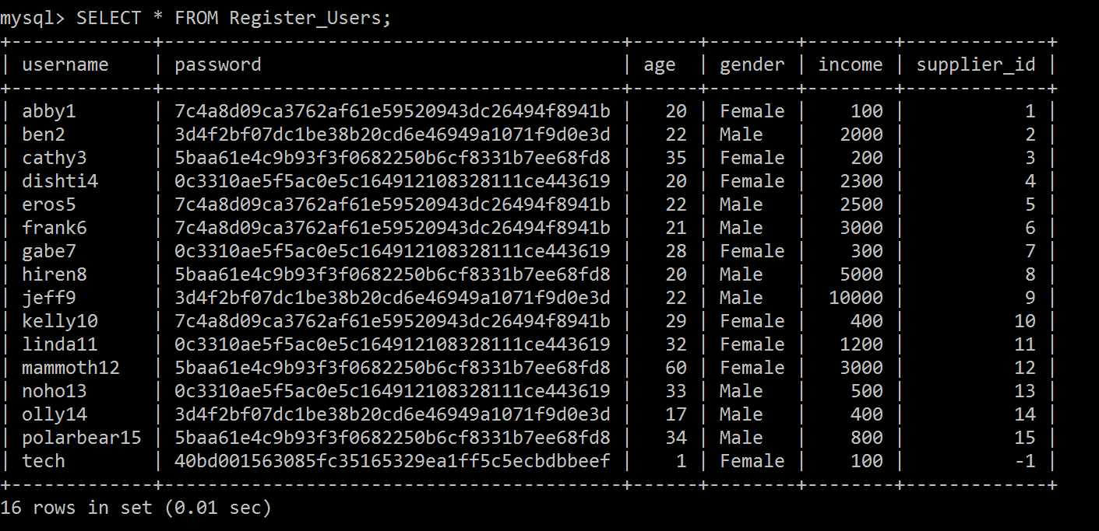

**Table 16: Sale Table**

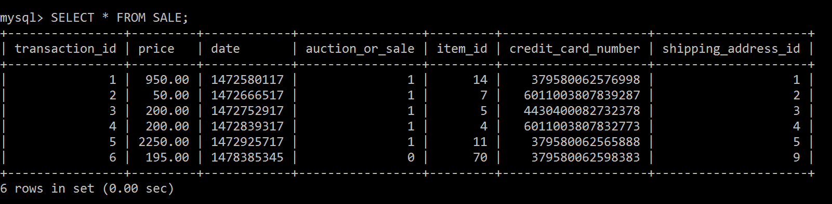

**Table 17: Sales_Item Table**

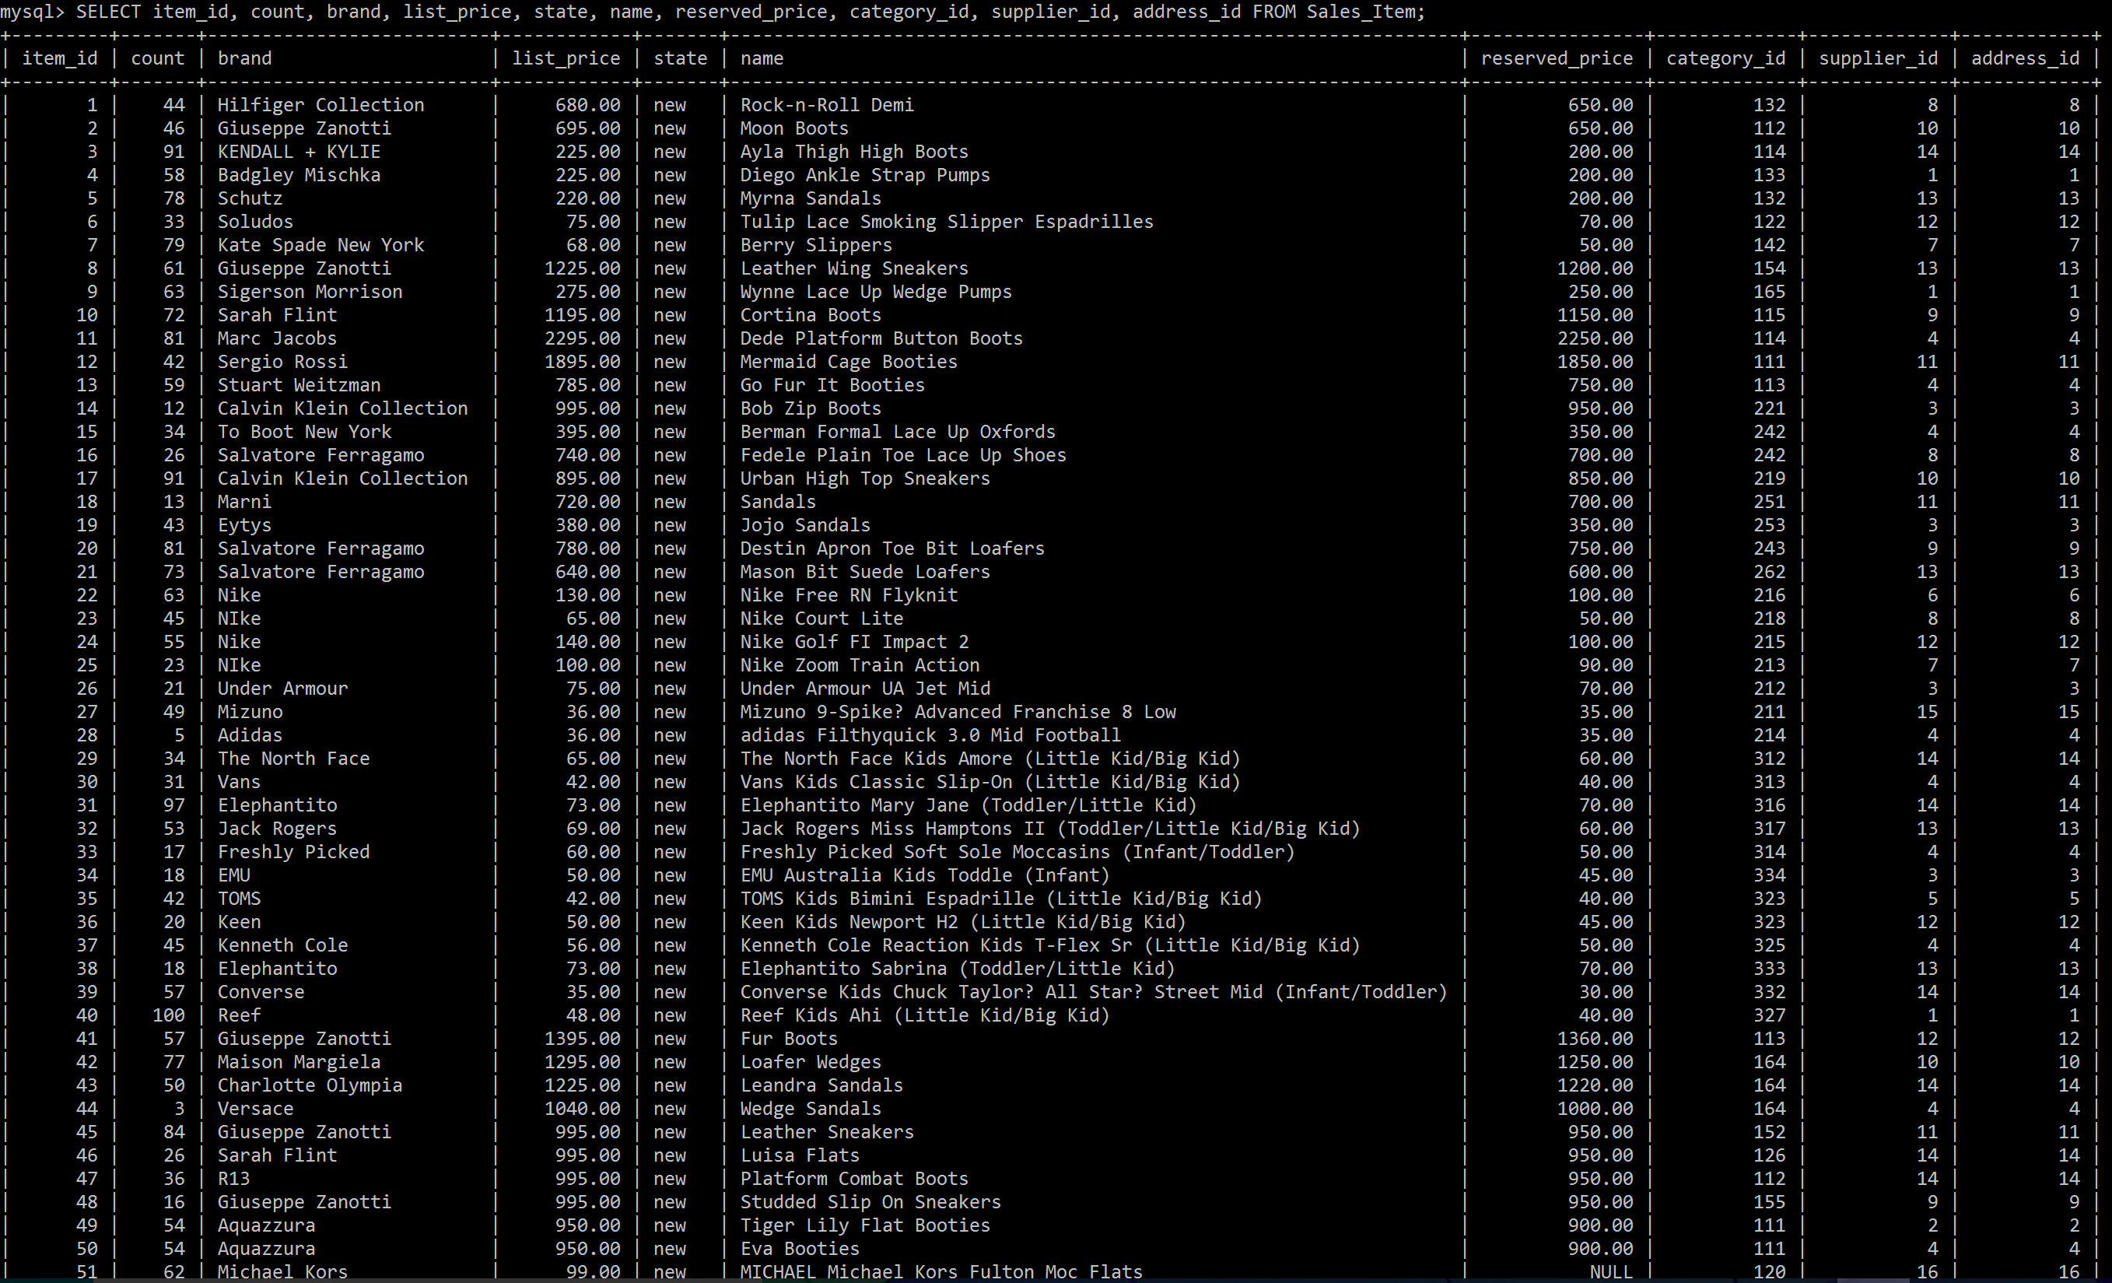

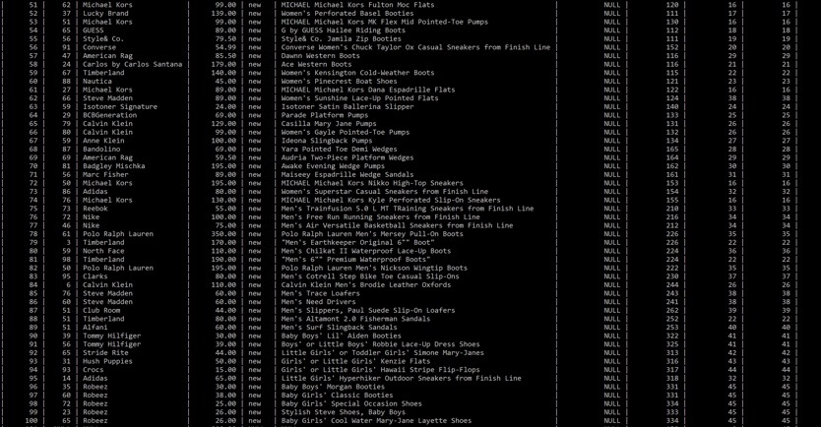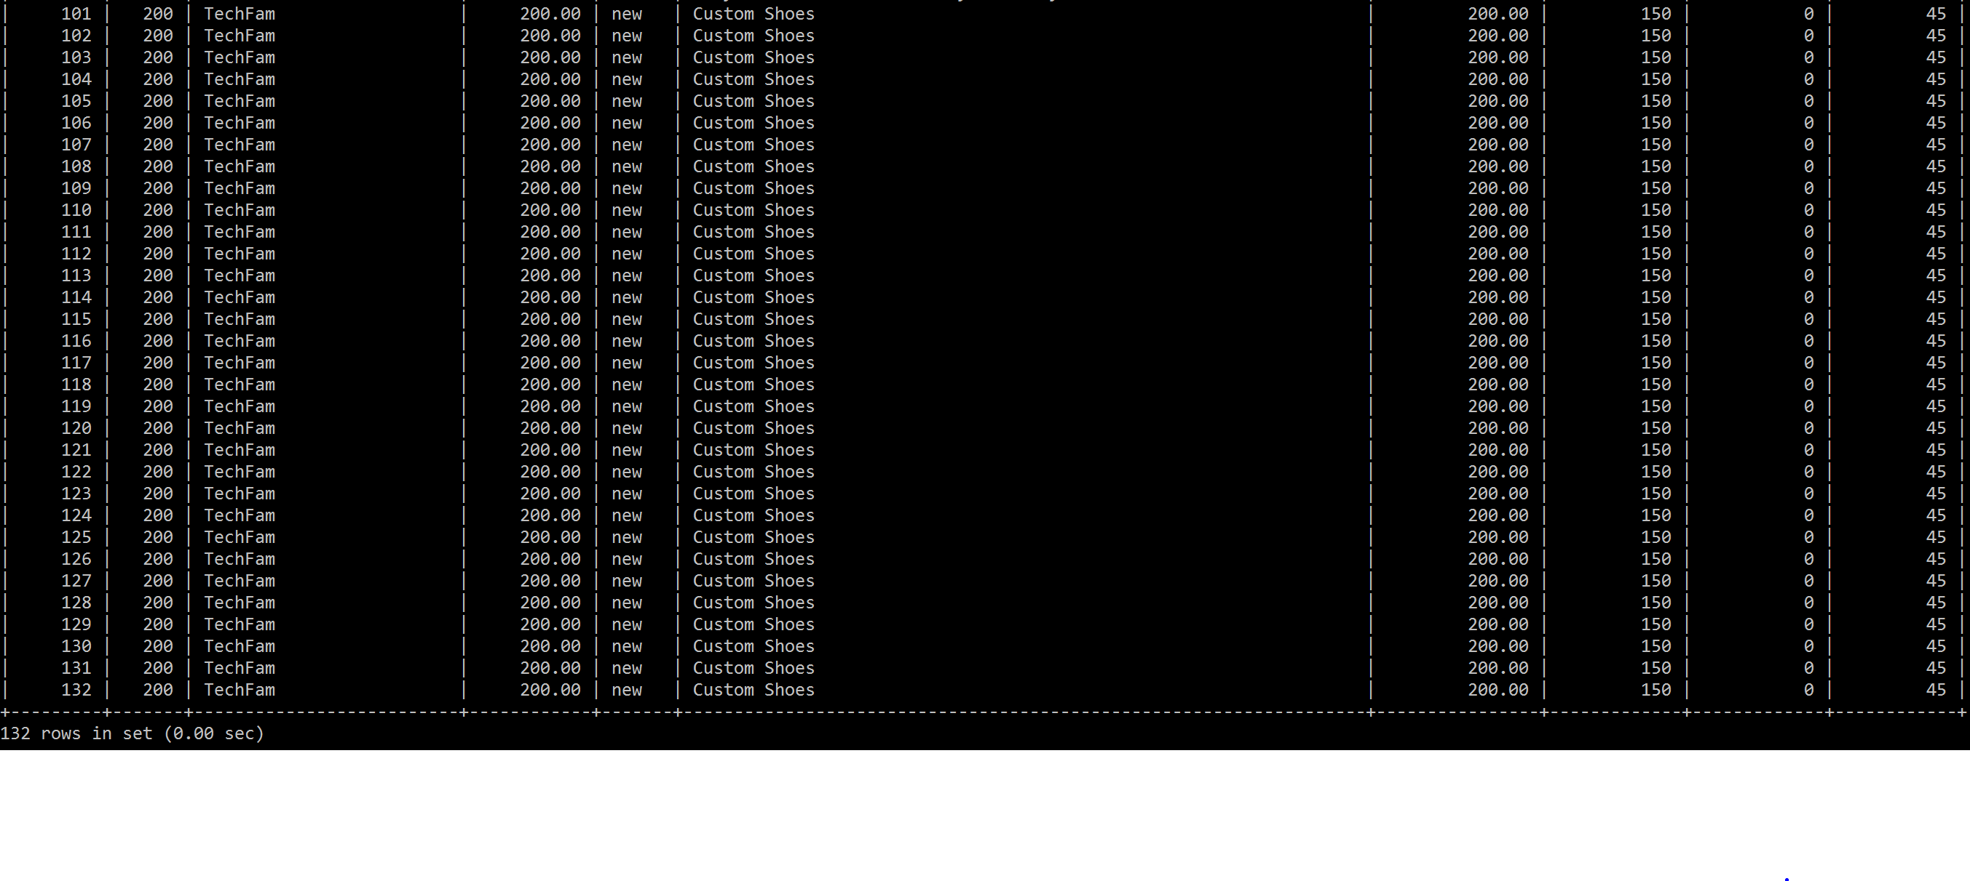

**Note that this table also has a description column, but due to the size of the data, it could not be fit**

**Table 18: Suppliers Table**

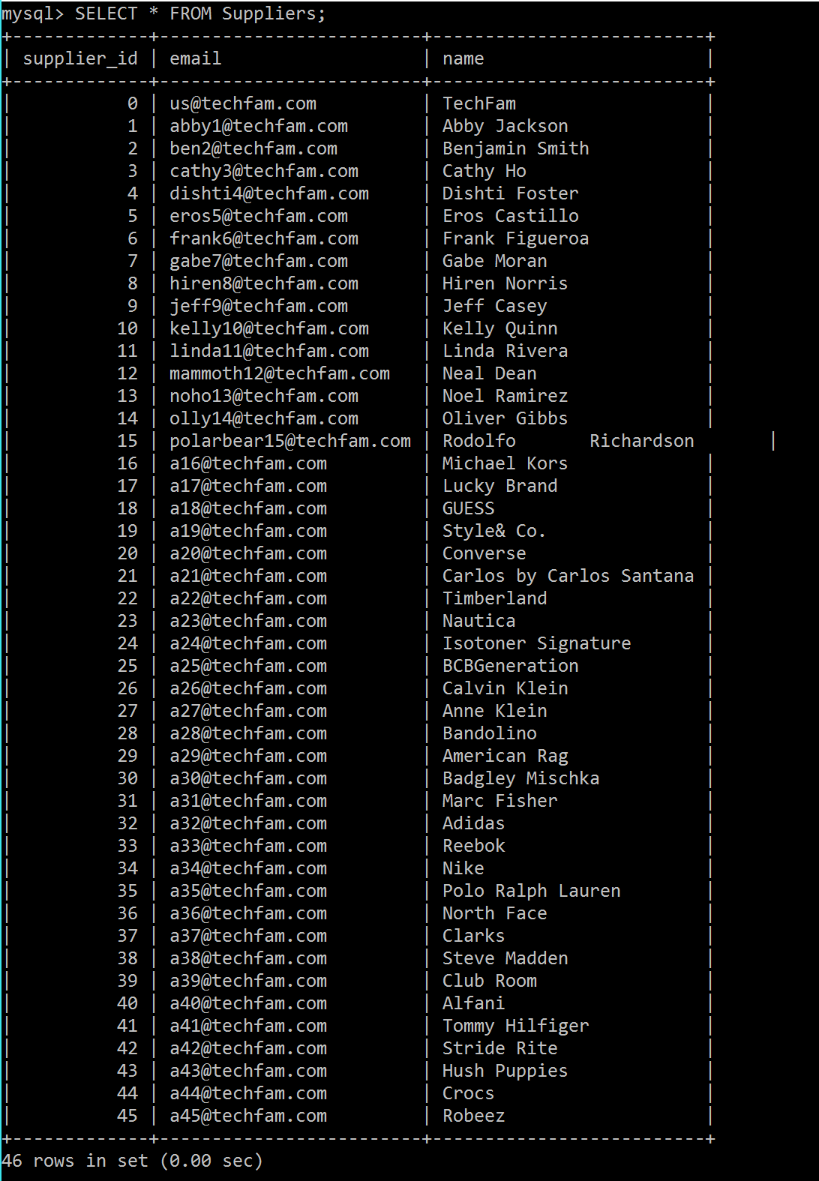

**Table 19: UPS Table**

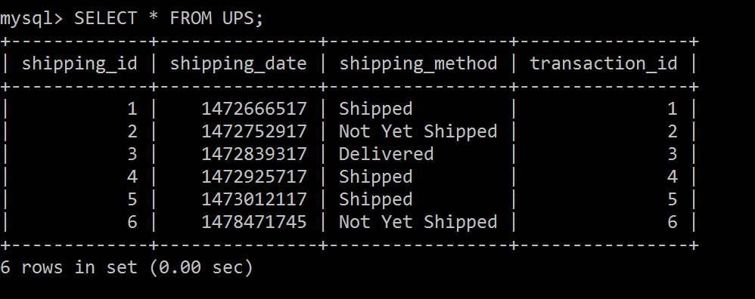

**Table 18: Item_Review**

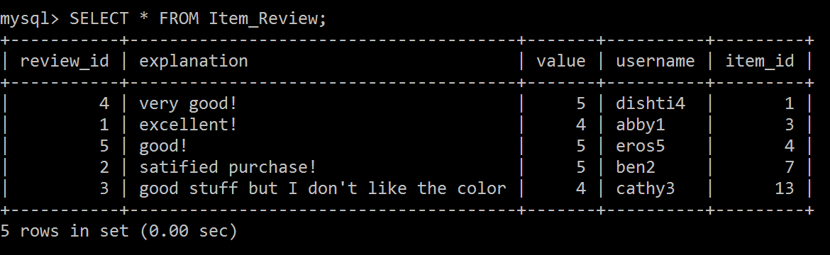

1. **WORKS CITED**

1. "Amazon." Amazon. N.p., n.d. Web. 13 Sept. 2016.

2. Caleres. *Shoes, boots, sandals - famous footwear online*. 2016. Web. 15 Sept. 2016.

3. "EBay." *Electronics, Cars, Fashion, Collectibles, Coupons and More*. N.p., n.d. Web. 15 Sept. 2016.

4. "Feedback Scores, Stars, and Your Reputation." Feedback Scores, Stars, and Your Reputation. N.p., n.d. Web. 13 Sept. 2016.

5. Harden, Seth. "Footwear Industry Statistics." Statistic Brain. N.p., 03 Sept. 2016. Web. 15 Sept. 2016.

6. "Official Store. Nike.com." N.p., n.d. Web. 15 Sept. 2016.

7. "Online Shoes, Clothing, Free Shipping and Returns| Zappos.com." Online Shoes, Clothing, Free Shipping and Returns| Zappos.com. N.p., n.d. Web. 15 Sept. 2016.

8. "Shoes, Boots, Sandals, Handbags, Free Shipping! | DSW.com." *Shoes, Boots, Sandals, Handbags, Free Shipping! | DSW.com*. N.p., n.d. Web. 15 Sept. 2016.

9. "The Purpose of Weekly Status Reports." Reportingadvice. N.p., 2013. Web. 14 Sept. 2016.

10. "United States." UPS Developer Kit. N.p., n.d. Web. 14     Sept. 2016.

11. Women’s shoes, boots, Handbags & clothing online. 2010. Web. 15 Sept. 2016.

12. "Five Advantages & Disadvantages Of MySQL." *Datarealm*. N.p., 2016. Web. 14 Oct. 2016.